

WHO COVID-19

preparedness and response progress report

1 FEBRUARY TO 30 JUNE 2020

# CONTENTS

FOREWORD FROM THE DIRECTOR-GENERAL 01

ABOUT THIS DOCUMENT 02

KEY RESULTS 03

CONTEXT AND RESPONSE STRATEGY 05

A national and global preparedness and response strategy 05

Complementing a whole-of-UN approach 07

Financing the response to date 07

RESPONSE IN ACTION 13

International coordination and support 13

Coordination 13

New partnerships 13

© World Health Organization 2020 Some rights reserved. This work is available under the Creative Commons Attribution-NonCommercialShareAlike 3.0 IGO licence (CC BY-NC-SA 3.0 IGO; <https://creativecommons.org/licenses/by-nc-sa/3.0/igo>)

Under the terms of this licence, you may copy, redistribute and adapt the work for non-commercial purposes, provided the work is appropriately cited, as indicated below. In any use of this work, there should be no suggestion that WHO endorses any specific organization, products or services. The use of the WHO logo is not permitted. If you adapt the work, then you must license your work under the same or equivalent Creative Commons licence. If you create a translation of this work, you should add the following disclaimer along with the suggested citation: “This translation was not created by the World Health Organization (WHO). WHO is

not responsible for the content or accuracy of this translation. The original English edition shall be the binding and authentic edition”.

Any mediation relating to disputes arising under the licence shall be conducted in accordance with the mediation rules of the World Intellectual Property Organization.

The designations employed and the presentation of the material in this publication do not imply the expression of any opinion whatsoever on the part of WHO concerning the legal status of any country, territory, city or area or

of its authorities, or concerning the delimitation of its frontiers or boundaries. Dotted and dashed lines on maps represent approximate border lines for which there may not yet be full agreement. The mention of specific companies or

of certain manufacturers’ products does not imply that they are endorsed or recommended by WHO in preference to others of a similar nature that are not mentioned. Errors and omissions excepted, the names of proprietary products are distinguished by initial capital letters. All reasonable precautions have been taken by WHO to verify the information contained in this publication. However, the published material is being distributed without warranty of any kind, either expressed or implied. The responsibility for the interpretation and use of the material lies with the reader. In no event shall WHO be liable for damages arising from its use.

Epidemiological analysis to inform the response 14

Risk communication and community engagement 17

Laboratories and diagnostics 19

Technical expertise, guidance, and support 19

Case management and continuity of essential health services and systems 21

Operations support and logistics 22

Travel and trade 22

Scaling up country preparedness and response 24

Country-level coordination, planning, and monitoring 25

Risk communication and community engagement 27

Surveillance, case investigation, points of entry, national laboratories 29

Infection prevention and control, case management, and continuity

of essential health services and systems 33

Operational support and logistics 35

Accelerating priority research and innovation 37

A Global Research Roadmap and call to action 37

Solidarity trial 39

Beyond Solidarity 39

Accelerating the development of a safe and effective vaccine 41

THE ROAD AHEAD 45

**FOREWORD** **ABOUT** **THIS** **DOCUMENT**

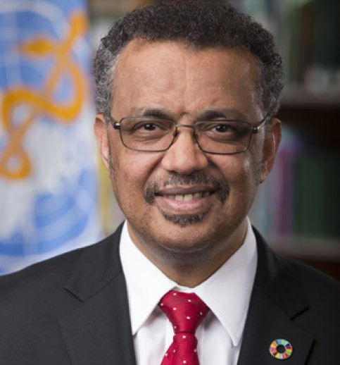More than six months since the world first learned of what we now call COVID-19, the time is

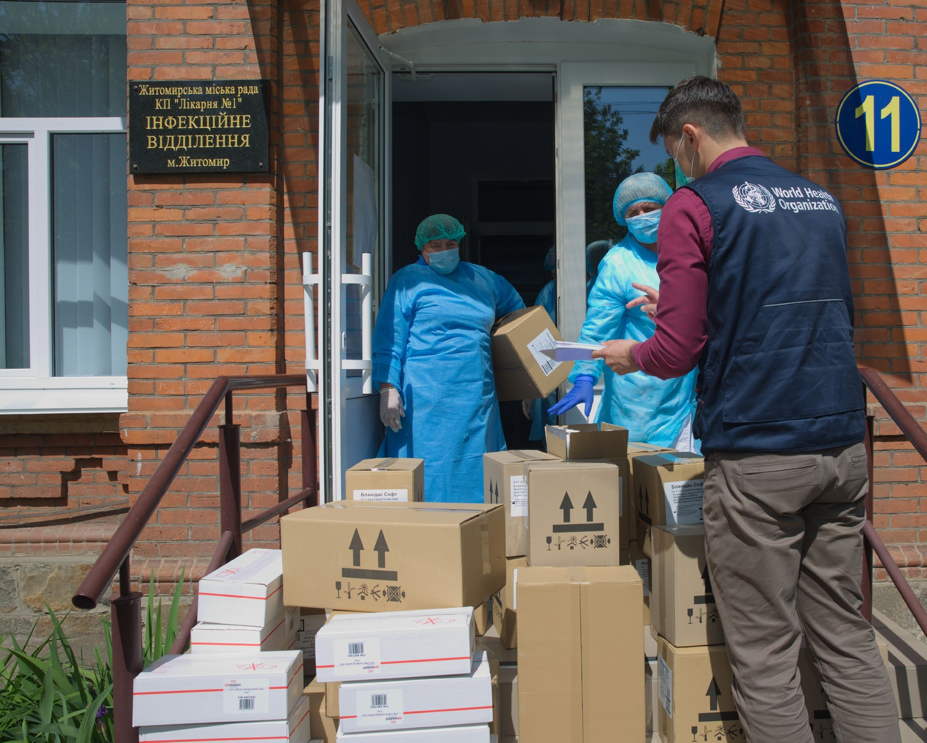

Credit: WHO

On 23 April 2020, the WHO country office in Ukraine supplied more than 65 000 items

right to take stock of where we are in the outbreak and how the world has responded.

The pandemic has already taken a terrible toll. By the end of June 2020, WHO had received reports of almost 10 million cases and half a million lives lost. The pandemic continues to accelerate; at the current rate, cases are doubling around every six weeks. We are facing a moment of great danger. We can only prevail if we stand together in global solidarity.

COVID-19 will always take the path of least resistance. We know that when countries take a comprehensive approach based on fundamental public health measures and a whole- of-society approach, COVID-19 can be brought under control, saving lives and enabling

societies and economies to function. But in most of the world the virus is not under control – it is thriving on delay, denial, and division.

The world has shown that we are stronger when we act together with a common purpose. Over 5000 patients in more than 20 countries have joined WHO’s Solidarity Trial, which will continue to answer questions about which treatments are most effective. More than 600 donor contributions have helped fund more than 108 COVID-19 national plans through the WHO Partners Platform.

Through the end of June, the joint expertise and purchasing power of agencies brought together by the COVID-19 Supply Chain System had obtained 140 million items of personal protective equipment, 4.5 million laboratory test kits, and 5 million sample collection kits available for delivery throughout July and August 2020. The COVID-19 Solidarity Response Fund for WHO raised more than US$224 million to support the response.

The Global Research Forum brought together manufacturers, regulators, academics, national governments, civil society and international organizations to agree on a global roadmap to accelerate priority research and development. The Access to COVID-19 Tools (ACT) Accelerator has been launched to ensure priority research is funded, and that new therapeutics, diagnostics and vaccines are available on the basis of need.

By working with expert networks and collaborating centres around the world, in a matter of months WHO has published 130 guidance documents on various aspects of preparedness and response in different contexts, constantly updated as our knowledge of the virus and how best to beat it evolves. Through online and in-person training, technical missions and remote support, WHO regional offices have helped countries to translate guidance and strategies into national plans; more than 80% of countries now have such a plan, while WHO’s global and regional platforms, country offices, and collaborative initiatives such as the Global Outbreak Alert and Response network have helped to implement these plans on the ground.

We have achieved a lot together, but our greatest challenges still lie ahead. As the pandemic continues to accelerate, the threat of COVID-19 is compounded by the increased risk of outbreaks of vaccine-preventable diseases caused by delays and suspensions to immunization programmes and the interruption of core health services. Of the 63 countries prioritized for operational assistance by WHO, more than two-thirds have suspended or postponed vaccination programmes due to COVID-19, while less than a quarter have identified and planned for the continuity of core health services.

Controlling COVID-19 is now the key to preventing the reversal of hard-won health and development gains in low-income countries that have taken decades to achieve. For the benefit of all, we must stand together against COVID-19.

Dr Tedros Adhanom Ghebreyesus WHO Director-General

WHO published the first COVID-19 Strategic Response and Preparedness Plan (SPRP) on 3 February, 2020. This report highlights the main points of progress that were made up to 30 June 2020 under the three objectives outlined in the SPRP: scaling up international coordination and support; scaling up country preparedness and response by pillar; and accelerating research and innovation. The report also discusses some

of the key challenges faced so far, and provides an update on the resource requirements for the next phase of WHO’s response as part of an unprecedented whole-of-UN approach to the pandemic.

of PPE to the Department of Health of Kyiv City Council. The PPE, including surgical masks, gloves, goggles, and gowns, was delivered to frontline health care workers in more than 30 hospitals in Kyiv.

# KEY RESULTS: FEBRUARY–JUNE

#### WHO-led UN Crisis- Management Team coordinating 23 UN entities across nine areas of work

36 447 goggles

shipped to 135 countries across all six WHO regions

140 million items of PPE,

4.5 milion PCR tests and 4.8 million sample

collection kits purchased through the COVID-19 Supply Chain System and ready for shipment through July and August

##### Proportion of countries and territories with a COVID-19 preparedness and response plan (target: 100%)

A plan explains the strategy to prepare and respond across all sectors of government and society. Evidence of a plan can include a framework of response for national and subnational authorities. WHO provides Operational planning guidelines to support country preparedness and response.

**46%**

**83%**

At 1 March

Incident-management support teams set up in 147 WHO Country Offices and six Regional Offices

Rapid publication of more than 130 technical



documents including in >30 languages

More than 3.7 million people registered on OpenWHO and able to access 100 COVID-19 online training courses in >30 languages



102 106 face shields

shipped to 135 countries across all six WHO regions

128 875 N95 masks

shipped to 135 countries across all six WHO regions

3 029 650 surgical masks shipped to 135 countries across all six WHO regions

Global roadmap to accelerate priority research

More than 3500 patients in over 20 countries enrolled in the global Solidarity clinical trial to assess the effectiveness of treatments for



COVID-19

31 countries used WHO Unity protocols to carry out epidemiological studies



 At 30 June

##### Proportion of countries and territories with a functional COVID-19 coordination mechanism (target: 100%)

**45%**

**92%**

Functional in this context means that the mechanism has the key components outlined in the Framework for a Public Health Emergency Operations Centre, including plans/procedures, physical infrastructure, information systems and standards, and human resources.

##### Proportion of countries and territories that have communicated COVID-19 prevention and preparedness messages to the population (target: 100%)

**43%**

**99%**

Prevention messages include actions for individuals to protect themselves, such as hand hygiene.

#### >150 global situation reports, synthesizing data from >215 countries and territories, accessed more than 40 million times



#### 203 379 gowns shipped to 135 countries across all six WHO regions



#### Access to COVID-19 Tools (ACT) Accelerator launched to accelerate the

development of medical countermeasures and ensure equitable access



##### Proportion of countries and territories that have a COVID-19 community engagement plan (target: 100%)

**19%**

**85%**

A community engagement plan should include at least four of the six recommended actions outlined in the SPRP.

#### More than 50 Emergency medical team deployments to national COVID-19 response across all six WHO regions

>125 countries active on the Partners Platform, with over 108 COVID19 national plans uploaded and almost 600 donor contributions

2 040 900 gloves

shipped to 135 countries across all six WHO regions

>1.5 million laboratory diagnostic kits shipped to 132 countries across all six WHO regions

#### Reference laboratory network supports testing in all WHO regions; 59 Member States have used the WHO shipping fund to send samples for analysis by international colloborating laboratories

##### Proportion of countries and territories that have access to laboratory testing capacity (target: 100%)

**85%**

**99%**

Laboratory testing capacity is defined as either in-country laboratory testing capacity, or access to international

laboratories that can provide results within 72 hours.

##### Proportion of countries and territories that have a COVID-19 clinical referral system (target: 100%)

**37%**

**75%**

A clinical referral system should outline how patients need to be managed and streamlined by the health care system (e.g. first points

of contact for individuals, fever clinics, designated referral facilities, hotlines etc. as relevant in the national context).

# CONTEXT AND RESPONSE STRATEGY

## An escalating global emergency

The COVID-19 pandemic has affected different countries in different ways, but across the world it has had three common, defining characteristics:

* Speed and scale: the disease has spread quickly, and its capacity for explosive spread means it has the potential to overwhelm even the most resilient health systems. More than 9 million people had been infected around the world and

almost 500 000 people were reported to have died by 28 June

(figure 1; table 1)

* Severity: an estimated [20% of cases](https://www.who.int/publications-detail/clinical-management-of-severe-acute-respiratory-infection-when-novel-coronavirus-(ncov)-infection-is-suspected) are severe or critical, with an increased risk of severe disease in older age groups and in those with certain underlying conditions.
* Societal and economic disruption: shocks to health and social care systems and measures taken to control transmission have had broad and deep socio-economic consequences.

Global incidence of COVID-19 has continued to accelerate

(Figure 2). By 28 June 2020, confirmed COVID-19 cases

reported to WHO approached 10 million, including 500 000 deaths. Within regions and countries, densely populated, poorer areas have been hardest hit. The Region of the Americas

has been the global centre of the pandemic since mid-April. While home to approximately 8% of the global population, the Americas accounted for over half (56%) of cases and almost two-thirds (64%) of global deaths during June 2020. Eastern Mediterranean, South-East Asian, and African countries, territories and areas have also reported an increase in the incidence of new cases over the same period. Overall incidence has stabilized in European and Western Pacific nations, although clusters of intense transmission continue to be observed in a number of countries.

## A national and global response strategy

#### **Figure** **1** Geographical distribution of reported COVID19 cases as at 28 June 2020

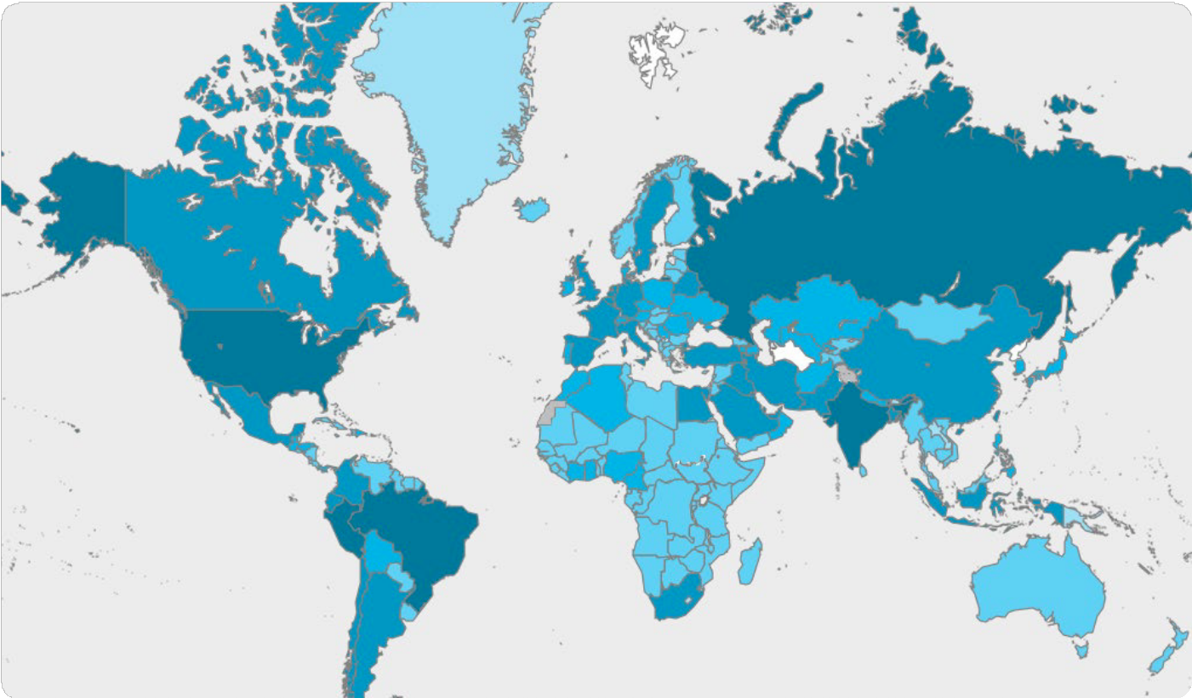

Confirmed cases

>300 000

50 001–300 000

10 000–50 000

101–10 000

1–100

No data

Not applicable

The boundaries and names shown and the designations used on this map do not imply the expression of any

opinion whatsoever on the part of the World Health Organization concerning the legal status of any country, territory, city or area or of its authorities, or concerning the delimitation of its frontiers or boundaries. Dotted and dashed lines on maps represent approximate border lines for which there may not yet be full agreement.

Data: World Health Organization

WHO published the first COVID-19 Strategic Response and Preparedness Plan ([SPRP](https://www.who.int/emergencies/diseases/novel-coronavirus-2019/strategies-and-plans)) on 3 February, 2020. The SPRP set out the two-pronged strategy that was needed to tackle the spread of the disease.

The SPRP set out three objectives for tackling the spread and limiting the harm caused by the disease. First, at the global level, the SPRP described the steps needed to rapidly establish international coordination to support countries to plan, finance and implement their response. Countries require authoritative real-time information on the evolving epidemiology and risks; timely access to essential supplies, medicines and equipment; and access to and training in the latest technical guidance and best practices. Second, also at the international level, the SPRP set out the necessary steps to ensure that there was a clear and transparent global process to set research and innovation priorities, to fast track and scale-up research and development, and ensure the equitable availability of candidate therapeutics, vaccines, and diagnostics. These global-level initiatives feed directly into the third crucial objective: scaling up preparedness and response operations at the national level. To that end,

the SPRP was complemented by draft [Operational Planning](https://www.who.int/publications-detail/draft-operational-planning-guidance-for-un-country-teams)

#### **Table** **1** Confirmed cases and deaths by WHO region (as at 28 June 2020)

|  |  |  |
| --- | --- | --- |
| **WHO** **region** | **Reported** **cases** | **Reported** **deaths** |
| Africa | 278 815 | 5785 |
| Americas | 4 933 972 | 241 931 |
| Eastern Mediterranean | 1 024 222 | 23 449 |
| Europe | 2 656 437 | 196 541 |
| South-East Asia | 735 854 | 20 621 |
| Western Pacific | 213 032 | 7420 |
| Other* | 741 | 13 |
| **Globa**l | **9** **843** **073** | **495** **760** |

*Cases and deaths reported from international conveyance.

#### **Figure** **2** Confirmed reported COVID19 cases by week up to 28 June 2020 by WHO region

1 200 000

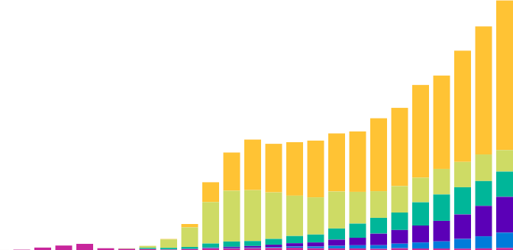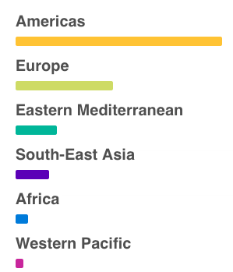

1 000 000

800 000

Reported confirmed cases

600 000

400 000

200 000

0

9 March 30 March 20 April 11 May 1 June 28 June

**Socio-economic** **response** **plan**

[Guidelines to Support Country Preparedness and Response](https://www.who.int/publications-detail/draft-operational-planning-guidance-for-un-country-teams), which outlined the priority steps and actions to be included in country-specific preparedness and response plans across the nine pillars of emergency health preparedness and response:

* Country-level coordination, planning, and monitoring;
* Risk communication and community engagement;
* Surveillance, rapid-response teams, and case investigation;
* Points of entry;
* National laboratories;
* Infection prevention and control;
* Case management;
* Operations support and logistics;
* Maintaining essential health services and systems.

Under the SPRP, WHO and partners at the global, regional and national level provide technical and operational support under each of these pillars, with priority given to countries with weak health systems and significant gaps in preparedness capacity for technical and operational implementation. To facilitate this prioritization, and to identify the overall financial envelope to fund priority preparedness and response support, a preliminary categorization of countries was done based on:

* Operational readiness capacities, based on a composite of the IHR (2005) [State Parties Annual Reporting](https://www.who.int/ihr/publications/WHO-WHE-CPI-2018.16/en/) tool (SPAR, which is a self-assessment); additional information from voluntary external evaluations; pandemic influenza preparedness plans; country readiness assessment for

health emergencies; missions to the countries; contemporary country-specific COVID-19 situation analyses; and humanitarian needs.

* Position on a continuum of transmission scenarios.

On 14 April WHO published a [Strategy Update](https://www.who.int/docs/default-source/coronaviruse/covid-strategy-update-14april2020.pdf?sfvrsn=29da3ba0_19) to the SPRP. The update drew on technical guidance published by WHO on preparing for and responding to COVID-19 since the beginning of the pandemic. The update also provided guidance for countries preparing for a phased transition from widespread transmission to a state of controlled transmission.

## Complementing a whole-of-UN, whole- of-government, whole-of-society approach

The SPRP and the Operational Planning Guidelines to Support Country Preparedness and Response are designed to underpin the health aspect of a broader whole-of-UN, whole-of-government, and whole-of-society approach to the COVID-19 crisis (figure 3). The SPRP complements separate plans to address the parallel [socio-economic emergency](https://unsdg.un.org/resources/un-framework-immediate-socio-economic-response-covid-19) caused by COVID-19. In addition, to address the needs

of countries where urgent humanitarian activities must be supported to continue in addition to urgent new health and non-health requirements due to COVID-19, WHO is part of the Inter-Agency Standing Committee (IASC) COVID-19 [Global](https://www.unocha.org/sites/unocha/files/Global-Humanitarian-Response-Plan-COVID-19.pdf)  [Humanitarian Response Plan](https://www.unocha.org/sites/unocha/files/Global-Humanitarian-Response-Plan-COVID-19.pdf) (GHRP; issued on 25 March

2020 and updated in May 2020) coordinated by the UN Office

for Coordination of Humanitarian Affairs (OCHA).

The GHRP sets out the most urgent health and humanitarian actions required to prepare and respond to COVID-19.

Under the umbrella of the IASC, WHO has worked with the International Federation of Red Cross and Red Crescent Societies (IFRC), International Organization for Migration (IOM), and the Office of the United Nations High Commissioner for Refugees (UNHCR) to produce [interim](https://interagencystandingcommittee.org/other/interim-guidance-scaling-covid-19-outbreak-readiness-and-response-operations-camps-and-camp)

[guidance](https://interagencystandingcommittee.org/other/interim-guidance-scaling-covid-19-outbreak-readiness-and-response-operations-camps-and-camp) to scale up readiness and response capacities for people in humanitarian settings.

The updated GHRP was informed by a new analysis of [Country Response and Preparedness status for COVID-19](https://www.who.int/publications-detail/updated-country-preparedness-and-response-status-for-covid-19-as-of-16-april-2020), based on the current COVID-19 situation in each country, current national capacity to prepare for and respond to COVID-19 transmission in line with the SPRP and Strategy Update, and humanitarian response plan status. As a result of this analysis, 63 countries have been prioritised for targeted operational and technical support from UN agencies and their partners (figure 4).

## Financing the response to date

The first analysis of country needs aligned to the SPRP

was published in February, and was the basis for an initial estimated resource envelope of US$675 million for the health aspects of the response, of which US$61.5 million were for WHO’s urgent preparedness and response activities for the period of February to end April 2020. This estimated resource enveloped was updated in May to take into account the evolution of the pandemic and the needs of priority countries, with a revised requirement of US$1.74 billion for WHO’s response activities up to the end of 2020.

As of 30 June 2020, WHO had received US$724 million from almost 60 donors (table 2), including more than US$103 million from the COVID-19 Solidarity Response Fund (Box 1). As of 30 June 2020, WHO had distributed US$702 million (97% of available funds) to Country Offices, Regional Offices, Headquarters, and for the purchase and global distribution of essential supplies (table 3). Of the US$702 million that has been distributed, 62% had been utilized by 30 June 2020.

More than half (US$322 million) of all funds distributed have gone to GHRP priority countries (table 4)

WHO is extremely grateful to all who have contributed, and is especially grateful for the donations of fully flexible funding that allow WHO to direct resources to where they are most needed. Having fully flexible funding is critical to responding

in real-time, and to responding equitably on the basis of need (see The Road Ahead, below).

#### **Table** **2:** Contributions to SPRP as of 30 June 2020

|  |  |
| --- | --- |
| **Contributor** | **Received**  **(US$)** |
| African Development Bank | 2 000 000 |
| Australia | 10 069 651 |
| Austria | 3 086 123 |

**Cont...**

**Table** **2** **cont.**

|  |  |
| --- | --- |
| Azerbaijan | 10 000 000 |
| BMGF | 11 217 758 |
| CAF | 750 000 |
| Canada | 19 489 648 |
| CCCU | 75 000 |
| CERF | 20 000 000 |
| China | 25 100 000 |
| Côte d'Ivoire | 439 351 |
| COVID MPTF | 4 951 252 |
| COVID-19 Solidarity Response Fund | 103 840 641 |
| Cyprus | 110 376 |
| Czech Republic | 258 176 |
| Denmark | 16 138 585 |
| Estonia | 108 578 |
| European Commission | 69 565 065 |
| Finland | 1 103 753 |
| France | 2 399 661 |
| Gavi, The Vaccine Alliance | 3 001 751 |
| Germany | 31 027 135 |
| Guinea | 193 670 |
| Holy See | 111 720 |
| Iceland | 204 290 |
| Ireland | 7 439 039 |
| Italy | 454 545 |
| Japan | 50 227 272 |
| King Baudouin Foundation | 3 250 000 |
| Kingdom of Saudi Arabia | 10 000 000 |
| Kuwait | 60 000 000 |
| Latvia | 108 577 |
| Liechtenstein | 320 513 |
| Luxembourg | 1 233 509 |
| New Zealand | 1 258 685 |
| Norway | 3 067 790 |
| Novartis International | 499 690 |
| OFID | 500 000 |
| Pandemic Tech | 20 000 |

|  |  |
| --- | --- |
| Republic of Korea | 3 300 000 |
| Serbia | 1 103 753 |
| Singapore | 500 000 |
| Slovakia | 220 507 |
| Slovenia | 67 873 |
| Standard Chartered Bank | 145 000 |
| Switzerland | 698 538 |
| Tetra Pak Export FZE | 242 825 |
| Thailand | 50 000 |
| UN OCHA | 22 107 464 |
| UNDP | 11 141 991 |
| UNFPA | 369 816 |
| UNICEF | 2 497 091 |
| United Kingdom | 108 354 100 |
| United States | 34 189 300 |
| Viet Nam | 50 000 |
| Vital Strategies/ Resolve to Save Lives | 1 433 923 |
| World Bank | 58 005 004 |
| World Bank/PEF | 5 861 975 |
| Total | 723 960 964 |

**Figure** **3** Complementary strategies make up the whole-of- UN approach

Protecting people Economic recovery Macroeconomic response Social cohesion

Essential health services and systems

Coordination, planning, and monitoring Accelerated research and development

Risk communication and community engagement

Surveillance Laboratories

Points of entry, and international travel Case management

Infection prevention and control Technical support and guidance Operational support and logistics

**Strategic** **preparedness** **and** **response** **plan**

**Global** **humanitarian** **response** **plan**

#### **Figure** **4** GHRP Priority countries, territories, and areas identified for targeted technical and operational support

#### **Priority** **countries** **territories** **or** **areas** Afghanistan, Angola, Argentina, Aruba*, Bangladesh, Benin, Bolivia, Brazil, Burundi, Burkina Faso, Cameroon, Central African Republic, Chad, Chile, Colombia, Costa Rica, Curaçao*, Djibouti, Dominican Republic, Democratic People’s Republic of Korea, Democratic Republic of the Congo, Ecuador, Egypt, Ethiopia, Guyana, Haiti, Iran, Iraq, Jordan, Kenya, Lebanon, Liberia, Libya, Mali, Mexico, Mozambique, Myanmar, Niger, Nigeria, oPt, Pakistan, Panama, Paraguay, Peru, Phillipines, Republic of Congo, Rwanda, Sierra Leone, Somalia, South Sudan, Sudan, Syria, Tanzania, Togo, Trinidad and Tobago, Turkey, Uganda, Ukraine, Uruguay, Venezuela, Yemen, Zambia, Zimbabwe.

* Aruba (Netherlands), Curaçao (Netherlands)

Source: OCHA. Disclaimer: The designations employed and the presentation of material in this publication do not imply the expression of any opinion whatsoever on the part of the Secretariat of the United Nations concerning the legal status of any country, territory, city or area or of its authorities, or concerning the delimitation of its frontiers or boundaries.

Countries included in GHRP in March

Countries added to GHRP in May

**Table** **3:** Overview of funds distributed to and utilized by major WHO region* (data as of 30 June 2020) **Table** **4:** Funds distribued by WHO to GHRP countries by major WHO region* (data as of 30 June 2020)

|  |  |
| --- | --- |
| **Eastern** **Mediterranean** **region** | |
| Afghanistan | 11 819 667 |
| Djibouti | 1 000 952 |
| Egypt | 897 024 |
| Iran, Islamic Republic of | 74 857 262 |
| Iraq | 9 850 000 |
| Jordan | 4 877 341 |
| Lebanon | 11 509 798 |
| Libya | 2 245 464 |
| occupied Palestinian territory | 11 424 877 |
| Pakistan | 7 160 178 |
| Somalia | 5 452 747 |
| Syrian Arab Republic | 8 384 202 |
| Yemen | 11 715 510 |
| Total | 161 195 022 |
| **European** **region** | |
| Turkey | 2 423 040 |
| Ukraine | 10 050 508 |
| Total | 12 473 548 |
| **South-East** **Asia** **region** | |
| Bangladesh | 13 095 731 |
| Korea, Democratic People's Republic of | 941 120 |
| Myanmar | 2 607 686 |
| Total | 16 644 537 |
| **Western Pacific region** | |
| Philippines | 5 375 509 |
| Total | 5 375 509 |

|  |  |
| --- | --- |
| **Region** **of** **the** **Americas** | |
| Argentina | 495 904 |
| Bolivia | 1 033 080 |
| Brazil | 607 112 |
| Chile | 437 897 |
| Colombia | 2 329 444 |
| Costa Rica | 417 234 |
| Dominican Republic | 1 009 593 |
| Ecuador | 1 025 137 |
| Haiti | 9 696 709 |
| Mexico | 1 463 792 |
| Panama | 7 433 357 |
| Paraguay | 1 215 317 |
| Trinidad and Tobago | 551 927 |
| Uruguay | 248 363 |
| Venezuela | 2 838 393 |
| Total | 30 803 259 |
| **Grand** **total** | **322** **517** **186** |

|  |  |
| --- | --- |
| **Country,** **territory,** **or** **area** | **Funds** **distributed**  **(US$)** |
| **African** **region** | |
| Angola | 1 026 977 |
| Benin | 676 015 |
| Burkina Faso | 5 956 217 |
| Burundi | 334 000 |
| Cameroon | 3 965 575 |
| Central African Republic | 3 461 370 |
| Chad | 4 741 555 |
| Congo, The Democratic Republic of the | 16 954 382 |
| Ethiopia | 10 124 839 |
| Kenya | 3 719 405 |
| Liberia | 1 424 201 |
| Mali | 1 184 579 |
| Mozambique | 822 053 |
| Niger | 1 208 579 |
| Nigeria | 17 140 586 |
| Republic of the Congo | 1 397 649 |
| Rwanda | 591 956 |
| Sierra Leone | 1 090 059 |
| South Sudan | 12 293 495 |
| Tanzania, United Republic of | 2 003 900 |
| Togo | 1 442 664 |
| Uganda | 2 894 129 |
| Zambia | 851 126 |
| Zimbabwe | 720 000 |
| Total | 96 025 311 |

|  |  |  |  |
| --- | --- | --- | --- |
|  | **Distributed** (**US$**) | **Utilized** (**US$**) | **Proportion**  **utilized** |
| Regional Office for Africa | 126 705 622 | 55 133 435 | 44% |
| Regional Office for the Americas | 53 258 844 | 19 295 203 | 36% |
| Regional Office for the Eastern Mediterranean | 127 819 999 | 59 163 745 | 46% |
| Regional Office for Europe | 63 721 276 | 33 328 692 | 52% |
| Regional Office for South-East Asia | 50 515 526 | 24 149 432 | 48% |
| Regional Office for the Western Pacific | 34 498 807 | 15 489 723 | 45% |
| Headquarters | 33 539 617 | 25 200 141 | 75% |
| Essential global supplies | 231 784 738 | 213 444 192 | 92% |
| **Total** | **702** **322** **608** | **437** **171** **130** | **62%** |

*Totals for Regional Offices include all funds distributed for countries within that region.

#### **Box** **1:** COVID-19 Solidarity Response Fund

The COVID-19 Solidarity Response Fund for the World Health Organization (WHO) enables corporations, individuals, foundations, and other

organizations around the world to directly support global efforts, led by WHO, to help countries prevent, detect, and respond to the COVID-19 pandemic.

The Solidarity Fund was created at the request of WHO by the United Nations Foundation (UNF)

and the Swiss Philanthropy Foundation (SPF). The intended use of the Solidarity Fund is to contribute towards funding the COVID-19 SPRP. The Solidarity Fund is a first-of-its-kind platform for the private sector and the general public to actively accelerate and support global efforts to contain and mitigate the ongoing pandemic by pooling flexible financial resources.

The Solidarity Fund has also given rise to a unique opportunity for inter-agency collaboration, as it funds a broad range of activities needed to combat the pandemic, including those undertaken by

key partners such as UNICEF, which has joined Solidarity Fund efforts to support vulnerable groups, and the World Food Program (WFP), which has joined the Solidarity Fund efforts to deliver

vital supplies to front-line responders during the pandemic. UNHCR, the UN Refugee Agency, has joined the fund to support refugee populations.

As of 30 June 2020, the COVID-19 Solidarity Response Fund has raised more than

US$224 million in donations and firm pledges from more than 529 000 individual donors, and more than 150 corporations and foundations. The second Solidarity Response Fund impact report has been published covering the period to 31 May 2020.

As at 30 June 2020, the Fund has allocated:

* US$117.8 million to WHO for response coordination and procurement and distribution of essential commodities;
* US$10 million to the Coalition for Epidemic Preparedness Innovations (CEPI) to accelerate COVID-19 vaccine research and development;
* US$10 million to UNICEF to support vulnerable countries with access to water, sanitation and hygiene, and basic infection prevention and control measures, and to provide access to care for vulnerable families and children;
* US$20 million to WFP to scale up a global logistics distribution system so that essential supplies can reach those most in need;
* US$10 million to UNHCR to support urgent needs such as risk communication and community engagement on hygiene practices, hygiene and medical supplies, establishment of isolation units in countries, and support global preparedness activities.
* US$5 million to the United Nations Relief and Works Agency for Palestine Refugees in the Near East to reduce the risk of infection and COVID-19 associated morbidity.
* US$5 million to WHO for the Africa Centres for Disease Control and Prevention (Africa CDC) to strengthen the response to the pandemic in Africa, including support for vulnerable women and girls;
* US$3 million to WHO for Unity Studies to enhance understanding of the characteristics of the virus and inform public health measures to limit transmission.

# RESPONSE IN ACTION

The scale of the COVID-19 crisis has required a significant shift in the international system to support countries to plan, finance

and implement their response, and WHO has led the international community in supporting these efforts across the world. Countries need authoritative real-time information on the evolving epidemiology and risks; timely access to essential supplies, medicines and equipment; the latest technical guidance and best practices; rapidly accessible and deployable technical expertise, access to an emergency health workforce and medical teams; and equitable access to newly developed vaccines, therapeutics, diagnostics and other innovations. This part of the report details some of the work that has been done to rapidly create and refine that global support system, the work that continues to improve it, and, most importantly, how this has translated into targeted, tangible operational and technical support on the ground in affected regions and countries.

### Epidemiological analysis to inform the response

In any disease outbreak, information is power. Epidemiological data are continuing to answer key questions about the epidemiological transmission features of COVID-19, helping to understand how it spreads in different contexts, and informing high-level strategic and operational decisions in the response. WHO has worked to ensure that the data that underpin these decisions are timely and accurate. WHO took rapid action with partners to establish a global surveillance

Under the case-based surveillance approach, 135 Member States, areas and territories have reported detailed information for more than 3.9 million cases using the WHO case report form. This represents close to 40% of total cases reported in the world, and is providing a vital resource for the analysis of transmission trends, allowing in-depth analysis on age, gender, comorbidities and outcomes since the beginning of the outbreak, as well as comparison between countries. At the aggregate level, 54 Member States report weekly minimum data sets, while transmission classifications are recorded and published daily for all countries. Moreover,

## International coordination and support

### Coordination

The SPRP, published on 3 February 2020, outlined the support that WHO and the international community stands ready to provide to enable all countries to prepare for and respond to COVID-19.

Overall UN coordination is provided through the UN Crisis Management Team, which was established on 4 February 2020. This is the highest possible level of crisis alert in the UN system, and this is the first time this mechanism has been activated for a public health crisis.

On 12 February 2020, the Operational Planning Guidelines to support the development of COVID19 National Plans were issued by WHO, and the  [COVID-19 Partners Platform](https://covid-19-response.org/) (also referred to as the Partners Platform) was launched on 16 March. The Partners Platform is a key coordination and governance tool. For the first time in a pandemic, national

people living under the duress of the pandemic, with a focus on the most vulnerable countries, groups, and people who risk being left behind. Together with WHO’s SPRP, these three complementary strategies provide a comprehensive overarching framework for the whole-of-UN coordinated response to the pandemic.

### New partnerships

WHO has actively engaged Member States in the response, and the WHO Director-General has provided advice and support to all requests coming from various Member State groupings such as the African Union, ASEAN, the EU, the G7, the G20, the G12 donors, as well as other regional multilateral organizations to support and finance the response. WHO advises Member States based on all available evidence and science, as it becomes available.

The World Bank Group, International Monetary Fund and other multilateral development banks and financial institutions including GAVI, the Vaccine Alliance, the Global Fund, and

system that gathers standardized data at global, regional

and country levels. Each day, WHO continues to collate, validate, analyse and disseminate official daily cases and deaths reported by 212 countries, territories and areas. These data are routinely published through a wealth of country and region-specific situation reports and dashboards, as well as globally via the WHO COVID-19 Dashboard – which has continued to receive between 1-2 million visitors per week.

Concurrently, regional and global WHO COVID-19 Situation Reports have continued to serve as a daily digest of global epidemiolocal trends and self-assessed country transmission classifications, while highlighting important recent events, guidance and actions taken by WHO and partners. These reports are viewed by over 3 million readers each week. WHO continues to also strengthen complementary surveillance at the level of individual cases where appropriate, and at the aggregate level for countries with sustained transmission.

in collaborating with international organizations, academic institutions and public health agencies, a global open content dataset of public health and social measures implemented by countries is maintained and updated regularly. Data

from all sources are quality checked, harmonized and maintained in a central database. The Health Information Pillar continues to produce guidance on important topics for Member States, such as updated guidance on surveillance strategies, contact tracing, and indicators to assess when considering adjustments to public health and social measures. Concurrently, the pillar continues to support several advisory groups, international public health agencies and modelling groups, to contribute toward strategic development and synthesis of epidemiological evidence and information to guide the global response.

authorities, UN Country Teams, and partners are able to

collaborate in the global COVID-19 response in real-time.

UNITAID, have provided emergency support for developing

countries to fast-track financial and operational facilities for

#### **In** **Focus:** Established partnerships bear fruit in Viet Nam, as GOARN delivers Go.Data

The COVID-19 Partners Platform:

* Facilitates planning aligned to international COVID-19 guidance developed in collaboration with national authorities and partners;
* Supports the monitoring of preparedness and response activities at national and subnational levels;
* Enables the costing of resource requests when they are not available at the country level;
* Provides visibility into the donor contributions that have been committed in the context of this outbreak.

To date more than 75% of WHO Member States (>150 countries, territories, or areas) have joined the Partners Platform, 108 COVID-19 national plans have been added to the system, and more than 70 donors have routed their contributions through the platform, totaling more than

US$3 billion. The Partners Platform is a unifying, transparent, global mechanism for use by the global partnership responding to emergencies such as COVID-19.

On 25 March 2020, OCHA issued the COVID-19 GHRP and activated the IASC scale-up protocol to mobilize the whole humanitarian system to support the GHRP’s implementation. Simultaneously, the UN Development Coordination Office (UNDCO) led the development of a UN framework for the immediate socio-economic response to COVID-19, which outlines an integrated support package offered by the UN Development System to protect the needs and rights of

COVID-19 response. Collaborative arrangements established under the *Global* *Action* *Plan* *for* *Healthy* *Lives* *and* *Wellbeing* *for* *All* are being used for the COVID-19 response.

The unique scale of the COVID-19 crisis has required WHO and the international community to reach out beyond their own capacity. To make private sector outreach and engagement more systematic and coordinated, WHO regularly convenes

a group of international associations including the World Economic Forum (WEF), International Chamber of Commerce (ICC), the International Organization of Employers, the UN Global Compact and others.

The WHO Director-General participated as a featured speaker in videoconference calls hosted by WEF with hundreds of

the world’s top companies. WHO released a joint statement with the ICC urging businesses to implement their business continuity plans, and issuing calls to action to national governments and national chambers of commerce to, among other things, work together with UN Country Teams and prioritize supply chains and cross-border flow of essential medical goods.

On 20 April 2020, WHO, the International Telecommunication Union (ITU) with support from UNICEF announced a partnership to work with telecommunication companies to text people directly on their mobile phones with vital health messaging to help protect them from COVID-19. These text messages will reach billions of people who aren’t able to connect to the internet for information.

The Global Outbreak Alert and Response Network ([GOARN](https://extranet.who.int/goarn/))

is a collaboration of institutions and networks that pools human and technical resources for rapid identification, confirmation and response to outbreaks of international importance, including the COVID-19 outbreak. WHO worked with GOARN partners to design, develop and deploy [Go.Data](https://www.who.int/godata): an outbreak investigation tool for field data collection during outbreaks of infectious diseases and public health emergencies.

The comprehensive outbreak investigation tool is now being used in a number of countries and by development partners. To date, there have been 35 Go.Data installations in institutions and/or countries, including Viet Nam in March

2020, when the World Health Organization (WHO) conducted a series of trainings in Ha Noi and Ho Chi Minh City and Nha Trang, as part of WHO’s support to the country’s response to the COVID-19 outbreak

Participants of the trainings in Viet Nam included epidemiologists, members of rapid response teams, and other frontline public health workers. Go.Data includes functionality for case investigation, contact tracing and follow- up, and visualization of chains of transmission, including secure real-time data exchange. These tools facilitate timely situation monitoring and response as investigations take place. The tool is also flexible enough so that response

teams can tailor its functionality to a variety of outbreak

scenarios or implement it for concurrent outbreaks.

“An efficient resource for data sharing and establishment of epidemiological links is key to the response to any disease outbreak. WHO, in collaboration with GOARN, has made tremendous efforts in rendering tools, such as Go.Data, to countries, including Viet Nam, as they manage

outbreaks of infectious diseases,” said Dr Kidong Park, WHO Representative in Viet Nam. “The introduction of Go.Data

in the country is very timely and will hopefully bring to the table innovative solutions, especially as the country now faces COVID-19. We look forward to working further with the Ministry of Health and other partners to ensure effective use of this tool in support of our responders on the ground.”

In addition to building the capacity of Viet Nam’s outbreak responders, WHO will continue to provide support in setting up and troubleshooting the Go.Data system in the country. Since January 2020, 150 institutions in 92 countries have expressed interest in receiving similar support to implement the outbreak investigation tool, and WHO is working with GOARN partners to meet this demand.

In addition to standard epidemiolgical data, we also need to gather data to deepen our understanding of transmission patterns, severity, clinical features and risk factors for infection, all of which were unknown at the start of the outbreak. To address these unknowns, WHO has provided Four Early Investigation Protocols (known as the [WHO Unity](https://www.who.int/emergencies/diseases/novel-coronavirus-2019/technical-guidance/early-investigations)  [Studies](https://www.who.int/emergencies/diseases/novel-coronavirus-2019/technical-guidance/early-investigations)) designed to rapidly and systematically collect and share data in a format that facilitates aggregation, tabulation, and analysis across different settings globally.

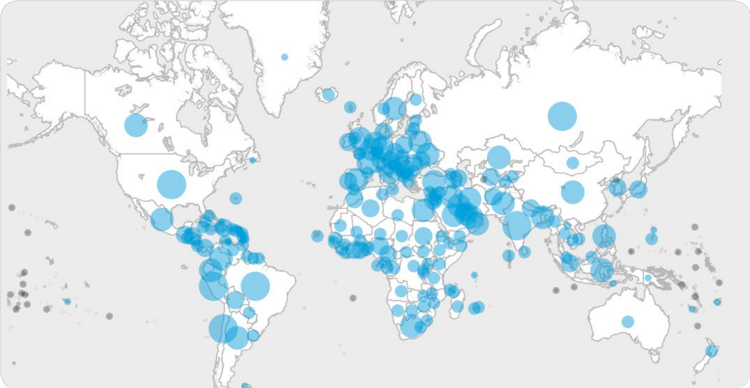

Data collected using these investigation protocols is used to continually refine recommendations for case definitions and surveillance, characterize key epidemiological features of COVID-19, help understand spread, severity, spectrum of disease, and impact on the community and to inform guidance for application of countermeasures such as case isolation and contact tracing.

The WHO COVID-19 dashboard presents verified epidemiological data that can be explored and visialized in a multitude of ways, from global views of the geographical distribution of the extent of the pandemic over time, to more detailed visualisations of epidemiological trends in individual countries, territories, and areas. Users can also download data

from the dashboard. Shown clockwise from top is the geographical distribution of total cases, country-level epi-curves (here showing the six countries with the most reported cases), and the global daily incidence of new cases and deaths since March 2020.

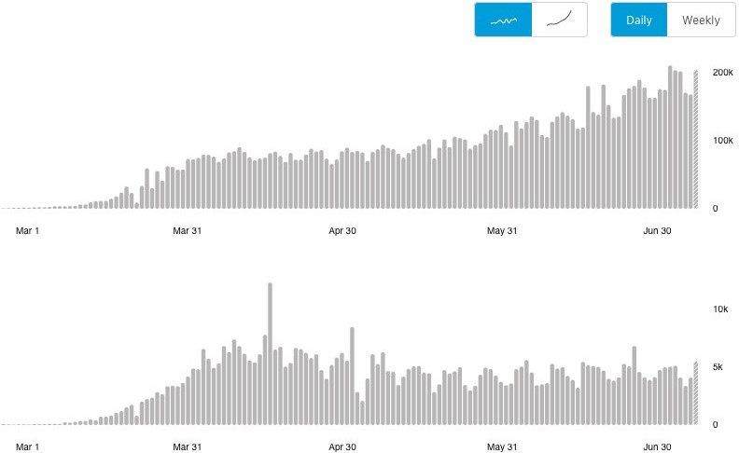

**Global** **Situation**

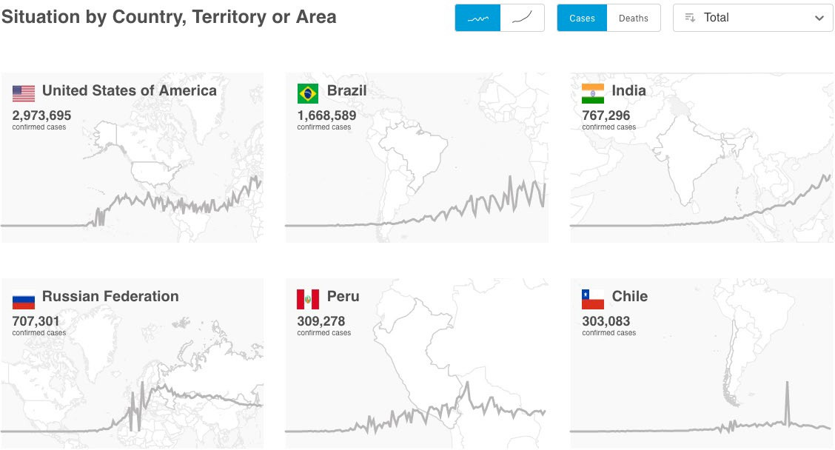

**Situation** **by** **Country,** **Territory,** **or** **Area**

### Risk communication and community engagement

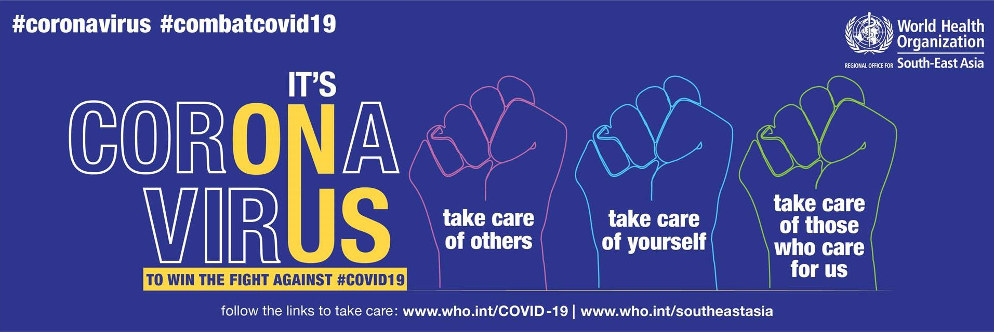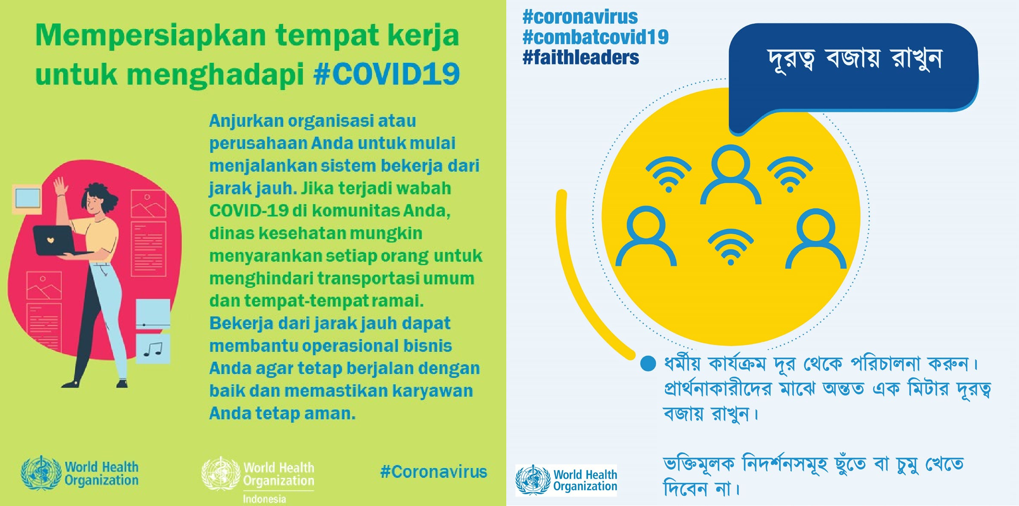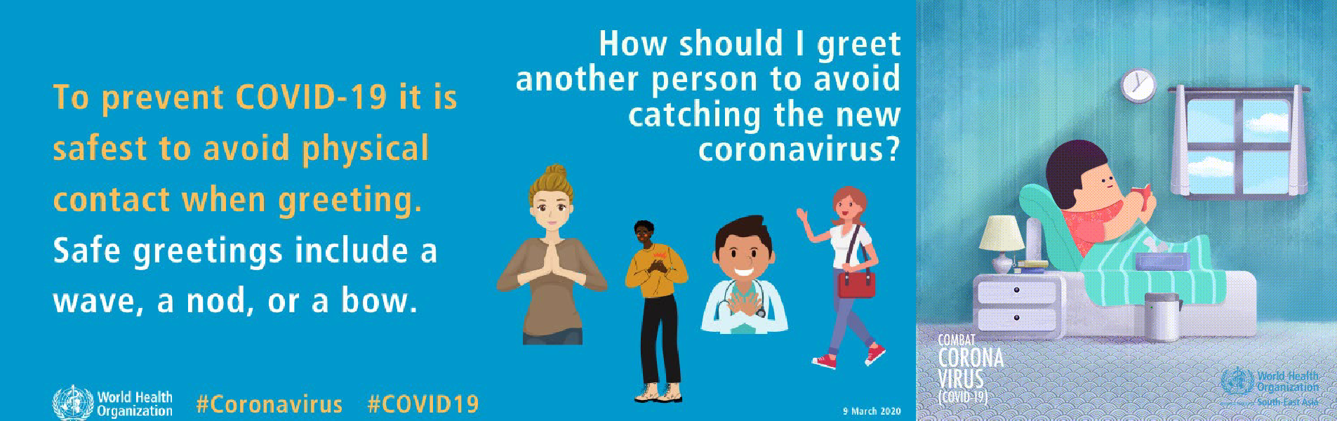

The 2019-nCoV outbreak and response has been accompanied by an “infodemic:” an over-abundance of information — some accurate and some not — that makes it hard for people to find trustworthy sources

and reliable guidance when they need it. Managing the COVID-19 pandemic and the related infodemic requires swift, regular and coordinated action from multiple sectors of society, communities and governments. To this end, WHO has developed an innovative initiative called the WHO Information Network for Epidemics ([EPI-WIN](https://www.who.int/teams/risk-communication)). EPI-WIN covers four strategic areas of work to respond to infodemics: (i) identifying, gathering and assessing real-time evidence to help form public health recommendations and policies; (ii) simplifying this

knowledge into actionable behavioral change messages;

(iii) amplifying impact by engaging communities and reaching out to key stakeholders in communities with tailored advice and messages; and (iv), quantifying, monitoring, and tracking the infodemic through social media technology platforms to guide the effectiveness of public health measures.

WHO EPI-WIN translates new science into evidence- based messaging and information products. By the end of April the EPI-WIN team had published more than 145 products, including FAQs, videos and animations, infographics and messaging, and mythbusters.

To better address audience and community needs, a key activity of EPI-WIN is its regular “engagement webinars” with key stakeholders to understand their concerns and information needs. This enables WHO to tailor advice and messages to help these stakeholders communicate the right messages to the audiences they interact with. Through this process, stakeholders amplify the right public health messages though established, trusted and recognized channels. EPI-WIN’s regular engagement calls target the most affected sectors. To date WHO has convened 60 technical webinars through EPI-WIN since January 2020, providing a channel for rapid information dissemination and a forum for participants to pose their own questions and shape the content of future webinars. Cumulatively, EPI-WIN COVID-19 live webinars have reached over 13 000 participants from 121 countries and territories.

The next goal for EPI-WIN is quantifcation of the extent and influence of information disseminated and consumed through the web, mass and social media, chat apps

and other information channels. WHO is currently working with partners to develop a framework for an evidence-based, quantifiable understanding of the global COVID-19 conversations through an analysis of online platforms. This, in turn, will inform the development of analytical capabilities for the real-time monitoring of audience conversations about COVID-19.

To promote community empowerment and trust throughout the COVID-19 response, and further strengthen risk communication and community engagement coordination at all levels, a Global Risk Communication and Community Engagement Collective Service has been launched by WHO, UNICEF and

IFRC with support from the Global Outbreak Alert and Response Network (GOARN) and the Bill and Melinda Gates Foundation. As part of a phased approach, two service hubs will be established in the African region, with dedicated staff first deployed in Senegal and Kenya with global coordination from Geneva.

The service will provide a dedicated coordination structure and improve greater collaboration among key stakeholders at all levels, supporting the coordinated delivery of the Risk Communication and Community Engagement strategy produced by WHO,

UNICEF, and IFRC aligned with the WHO COVID-19 SPRP and the COVID-19 Global Humanitarian Response Plan. The Collective Service will work across four strategic areas to:

* Strengthen coordinated approaches in order to maximize the sharing of resources, information and expertise at global, regional and country levels;
* Improve quality and shift the focus towards community engagement approaches grounded on social data, perceptions and community insights that regularly inform public health

measures, inter-agency standards and monitoring frameworks;

* Amplify the views and perspectives of communities, enabling

them to influence decision-making within the response;

* Strengthen local capacity and existing coordination mechanisms, through RCCE mentoring support and resource sharing with local actors working in the public health, humanitarian and development

sectors.

**In** **Focus:** Countering misinformation

WHO has joined forces with the communications teams at the Government of the United Kingdom and the Prime Minister’s office for an awareness campaign about the risks of incorrect and false information regarding the pandemic. “Stop The Spread” is a global campaign, rolled out on BBC World television, website and apps during May and June 2020.

The campaign aims to raise awareness among BBC audiences of the risks of misinformation on COVID-19. It encourages them to double check information from unreliable sources and promotes WHO and national health authorities as trusted sources of information.

In addition to the global TV and web channels, the campaign will also roll out through BBC digital apps in these 20 countries worldwide.

Africa - Ethiopia, Kenya, Nigeria, Sierra Leone, Tanzania, Zambia Asia – Bangladesh, India, Indonesia, Nepal, Thailand

Europe – Azerbaijan, Moldova Middle East – Libya, Tunisia

Latin America – Brazil, Argentina, Mexico, Paraguay

The UK government will also offer a toolkit of the campaign assets to partner governments to translate and use in their countries,

so there is a unified message across governments on this very

important topic.

BBC has provided its platforms for this campaign pro bono as part of its partnership agreement with WHO to amplify the importance of accurate health messages. The UK government has ensured the funding of the campaign and is leading tracking engagement.

### Laboratory and diagnostics

Diagnostic laboratory testing is a cornerstone of the management of the COVID-19 pandemic. It allows for the detection of cases to inform care and for the isolation of infected individuals to interrupt disease transmission.

Confirmatory testing also enables the disease to be tracked in the community, and for clusters of cases to be identified. WHO endeavors to ensure that all Member States have timely and accurate testing capacity for COVID-19. This is done through several mechanisms.

First, a reference laboratory network has been established across the six WHO regions, and recently expanded

to include 24 laboratories with expertise in virology, diagnostics, sequencing, and viral culture. These laboratories act to support Member States that currently do not have testing capacity or need to get confirmation of their initial test results while building in-country capacity. These same laboratories serve as a valuable source of support for strategic planning for the WHO HQ team,

and also provide guidance to the WHO Regional Office laboratory focal points. WHO also works through the operations support and logistics pillar to supply countries with essential laboratory equipment and consumables on the basis of need.

Second, through the WHO Global Influenza Surveillance and Response System (GISRS), countries are testing for COVID-19 disease in clinical specimens coming in from influenza sentinel surveillance sites every week. GISRS laboratories in 122 Member States are currently testing for COVID-19. Of these, 48 Member States tested 1.8 million specimens collected through GISRS systems and reported COVID-19 results to the WHO platform FluNet/FluID/ FluMart. Systematic sampling and standardized testing of patient samples from SARI and/or ILI sentinel sites is an efficient way to monitor SARS-CoV2 virus transmission in communities.

Importantly, two established GISRS systems have supported the COVID response from the beginning. First, an External Quality Assurance Program (EQAP) for COVID-19 was rapidly put in place through the WHO GISRS mechanism. As of 24 June, 234 laboratories in 161 Member States confirmed participation, 178 panels have been shipped, of which 95% (141 of 149 assessed)

were validated as accurate. In addition, a shipment project through the established GISRS shipping mechanism enabled rapid transport of samples to WHO reference laboratories for confirmatory testing. By the end of 24 June 2020, 88 shipments from 59 Member States have been made through the project.

For the beginning of the southern hemisphere influenza season, and in preparation for the upcoming northern hemisphere season 2020–2021, WHO has developed practical guidance, advocacy materials and

communications for countries to enhance vigilance for the threat of influenza and prepare for the co-circulation of influenza and SARS-CoV2 viruses.

response, genetic sequence data provided through the GISAID influenza genetic sequence database have the potential to give us key insights into COVID-19, and possible treatments. Since the start of the COVID-19 outbreak and the identification of the pandemic virus, laboratories around the world have generated viral genome sequence data with unprecedented speed, enabling real-time progress in the understanding of the new disease,

and in the research and development of candidate medical countermeasures. Sequence data are essential to design and evaluate diagnostic tests, to track and trace the ongoing outbreak, and to identify potential intervention options. From 1 February to 26 June 2020, 53 968 SARS-CoV2 genome sequences had been shared through the GISAID database, including over 53 511 full genomes.

.

### Technical expertise, guidance, and support

All of WHO’s operational, technical and research networks have been activated in the fight against COVID-19. Experts from around the world and frontline responders are reviewing all available evidence to develop and update technical guidance for countries to prepare and respond to COVID-19. Much has been learnt about COVID-19 in the more than six months since it was first identified, but there remain significant knowledge gaps that must be filled by ongoing surveillance and research activities.

Research protocols to address these gaps have been rapidly and transparently developed.

The first [comprehensive set of technical guidance](https://www.who.int/emergencies/diseases/novel-coronavirus-2019/technical-guidance) was published on 10 January 2020, and is being constantly reviewed and revised based on available evidence. Technical guidance is being adapted for different settings and contexts based on the intensity of transmission, the capacity of countries to implement public health measures, and available resources, and translate key actions required for countries through the EPI-WIN platform and other information products. Almost 4 million people have enrolled on the [OpenWHO](https://openwho.org/channels/covid-19) training platform, which has COVID-19-specific courses available in 30 languages, and has so far issued more than 860 000 certificates of completion. Direct technical support missions have been provided in all regions (see the scaling up country readiness and response section for more information).

Esri, the global leader in geographic information system (GIS) software, is providing a free and comprehensive ArcGIS package to all GOARN partners and ministries of health to support the COVID-19 response. WHO and GOARN partners are working

to facilitate online ArcGIS training to build and improve the operational capacity of partners. WHO is assessing GIS training needs and capacity among GOARN partners.

Direct technical assistance to Member States is also facilitated through GOARN, which has made over 400 offers of technical support. Experts have been deployed from 27 partner institutions and technical networks to provide support to countries directly and by remote assistance.

GOARN colleagues from UNICEF, IFRC, US CDC, and OCHA are embedded in the global COVID-19 incident management team and are supporting all pillars of response.

focal points worldwide, who are working closely with the EMT secretariat at WHO to continuously monitor, guide, and facilitate national and international COVID-19 response operations.

The EMT secretariat is involved in intensive discussions to strengthen capacity and support to countries in Africa.

In addition, EMTs worldwide are identifying technical experts and coordinators who can support integrated public health and clinical teams. By the end of June, a total of 23 EMTs had been internationally deployed, with a further 43 EMTs supporting national operations in the response to COVID-19. EMTs are deployed to all WHO regions, with the majority of EMTs deployed in Africa: Ghana, South Africa, Zambia, Senegal, Burkina Faso (two teams), Ethiopia, Cameroon, Algeria, the Democratic Republic of the Congo, Republic of the Congo, and Zimbabwe. The European region has received the next most deployments, with four international and two national EMTs deployed in Italy. At a conservative estimate, more than 4000 beds are supported by EMTs.

In addition, the [Global Health Cluster](https://www.who.int/health-cluster/en/) (GHC) continues to support Health Clusters in 27 countries to implement

the COVID-19 GHRP to respond and preserve existing humanitarian health action and commitments in line with the GHRP 2020. WHO and the GHC have coordinated inputs from partners on the first update of the Global Humanitarian Response Plan, including mental health and psychosocial services, gender-based violence, protection and specific needs of older people and migrants, minimum Sphere humanitarian standards, and issues related to Water, Sanitation and Hygiene (WASH) and the Integrated Food Security Phase Classification. Analysis is ongoing

to strengthen projections and service requirements for COVID-19 cases and wider humanitarian needs, and monitoring the impact of COVID-19 protection measures on access to essential health services. The Global Health Cluster is co-leading the new Global Information Management, Assessment and Analysis Cell (GIMAC) on

COVID-19 (along with OCHA, UNHCR and IOM) to support GHRP countries with analysis and monitoring.

The GHC COVID-19 Task Team was established in May to support partners to identify and adapt existing COVID-19 guidance to operational contexts in humanitarian settings, identify and share learning, and identify and address critical needs and gaps.

In addition to the direct impact of diagnostic testing on the

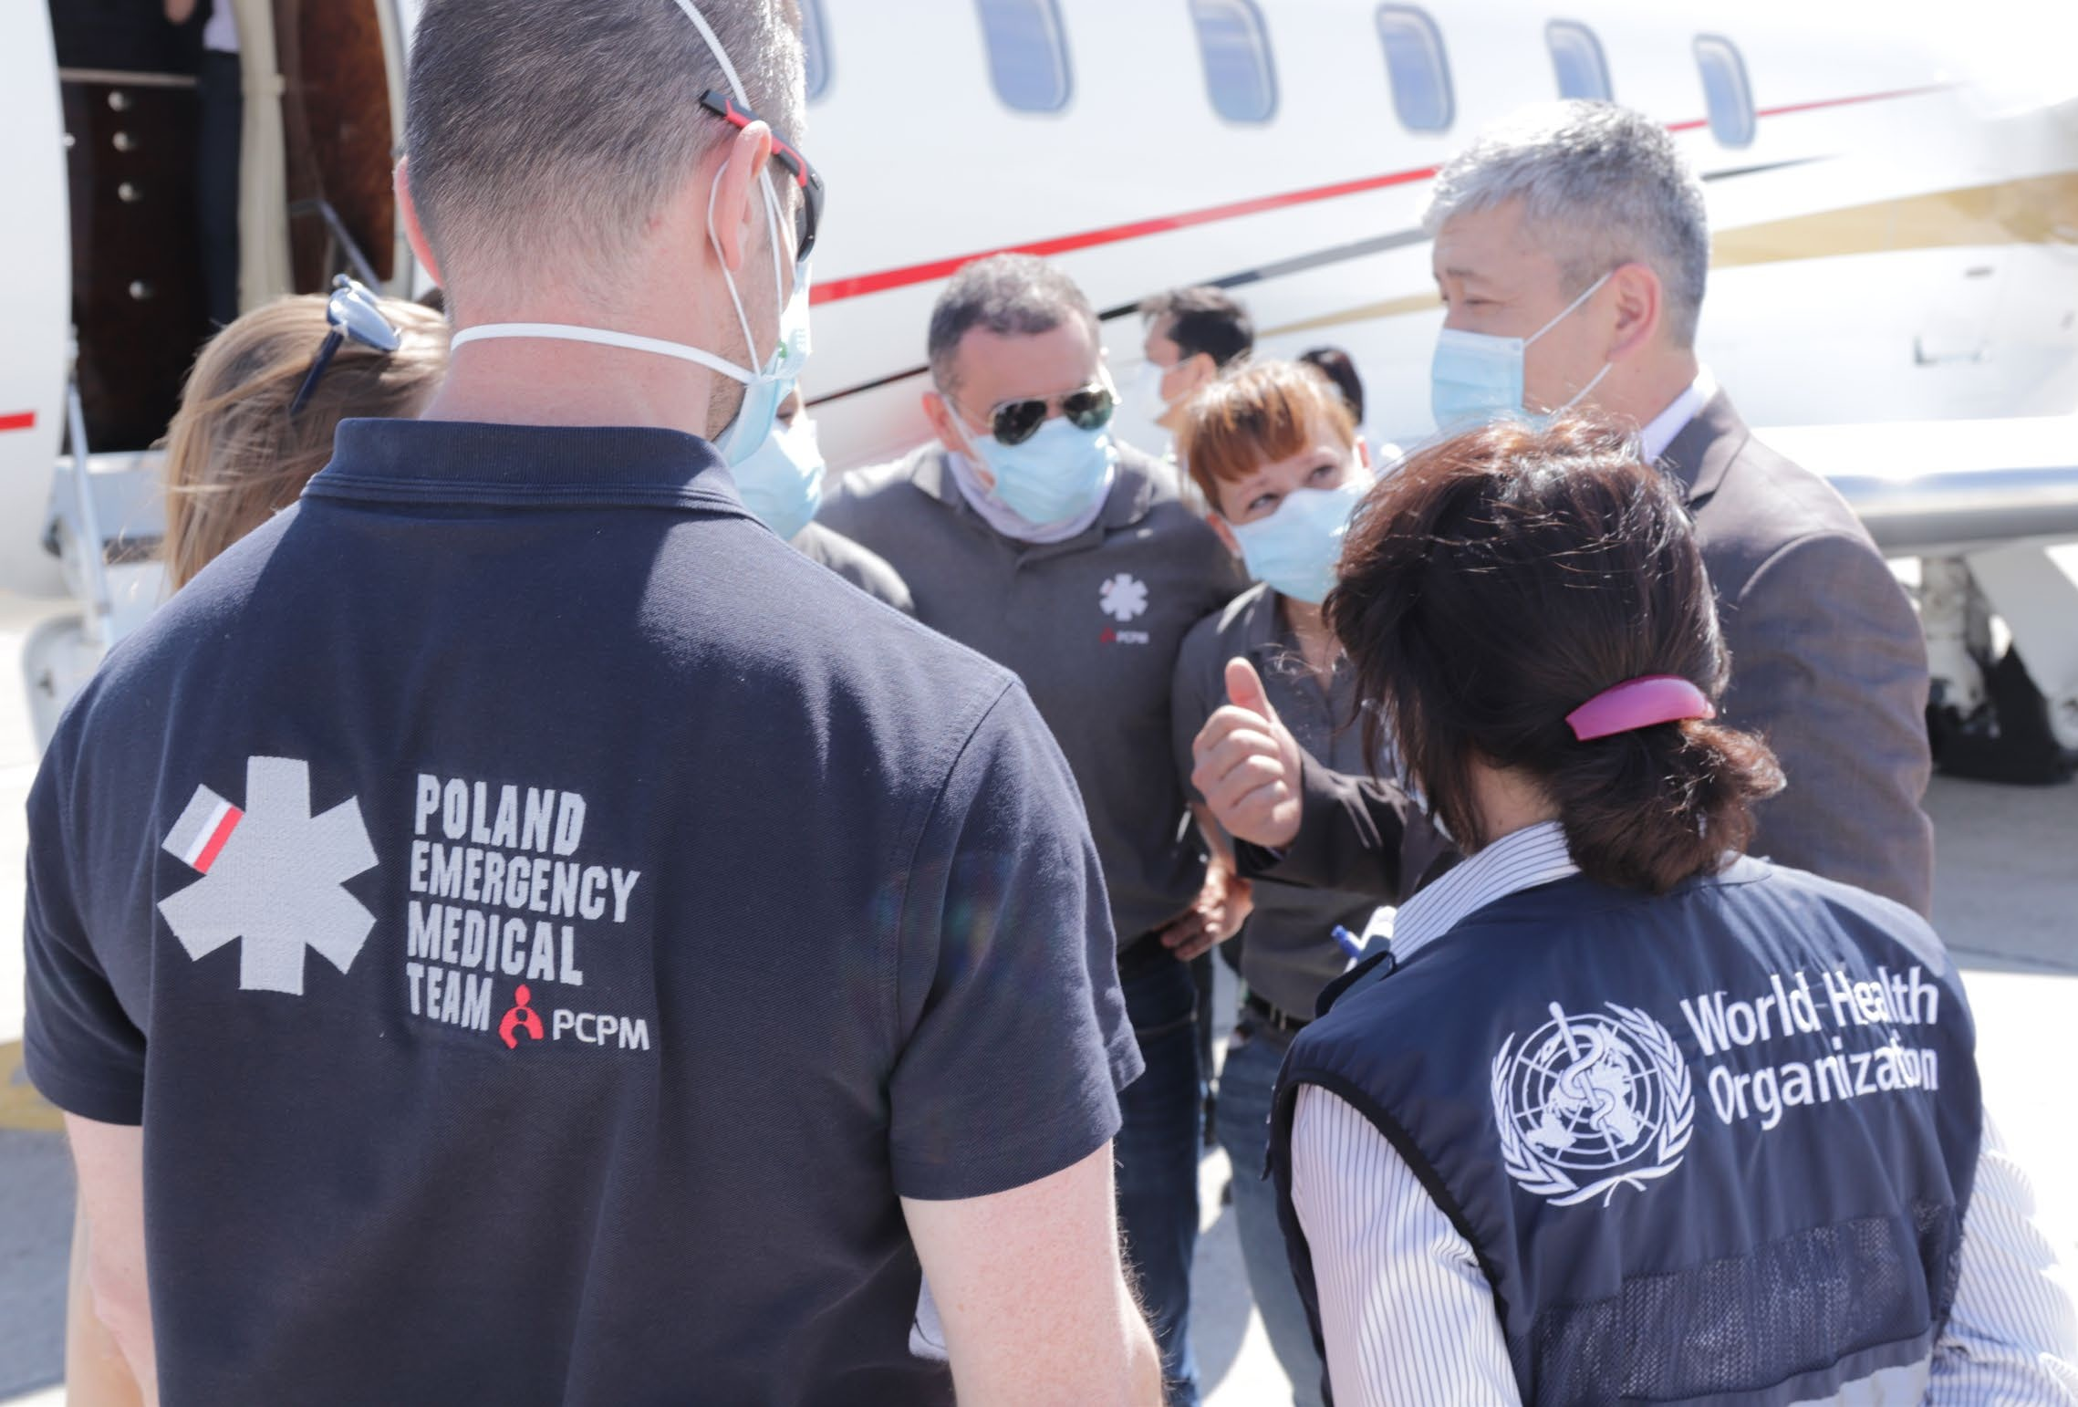

Credit: WHO

Access to emergency health workforce capacity is coordinated

through the over 100 [Emergency Medical Teams](http://origin.who.int/hac/techguidance/preparedness/emergency_medical_teams/en/) (EMTs) and

A Polish Emergency Medical Team arrives in Kyrgyzstan to boost case management capacity.

WHO has published and disseminated guidance on every aspect of the health response to COVID-19 in every context, adapted by region and country (and rapidly translated into local languages). Training of millions of individuals through technical missions and online platforms has helped to operationalize the guidance around the world.

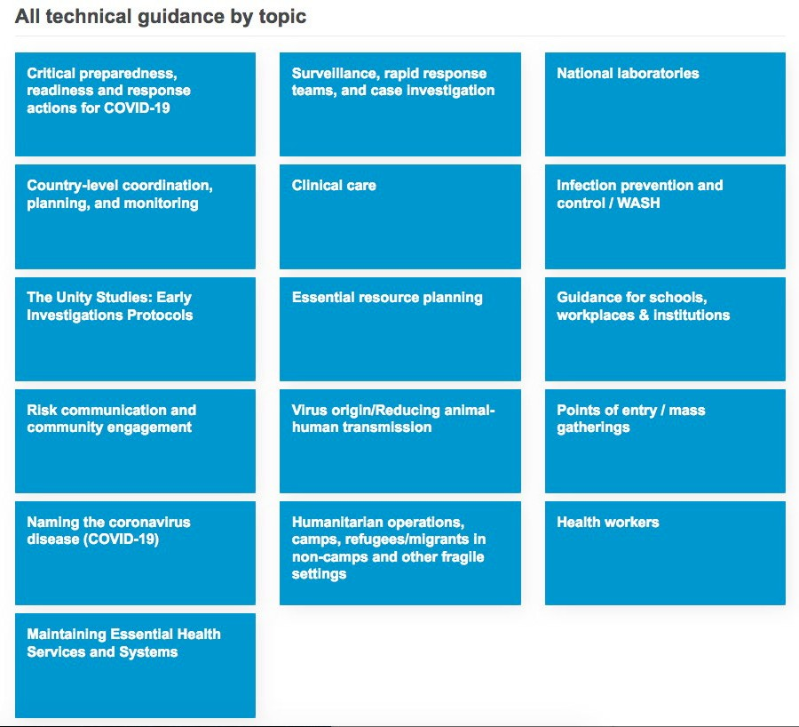

### Operations support and logistics

The global COVID-19 outbreak has led to an acute substantial shortage of essential supplies, including personal protective equipment, diagnostics, and supplies for clinical management. This has made the procurement and delivery of resources on the basis of need extremely challenging.

To overcome these challenges, a Supply Chain Task Force

co-chaired by WHO and WFP has been convened to establish an integrated [COVID-19 Supply Chain System](https://www.who.int/emergencies/diseases/novel-coronavirus-2019/covid-19-operations) (CSCS).

The Supply Chain Task Force includes representation from each participating organization (WHO, WFP, UNICEF, OCHA, World Bank, The Global Fund, UNOPS, UNDP, UNFPA, UNHCR, NGOs, Red Cross and Federation and other cluster partners).

The day-to-day operational activities under the Task Force are performed by the Supply Chain Inter-Agency Coordination Cell (SCICC), which ensures that COVID-19 needs are prioritized within the wider humanitarian response.

Three purchasing consortia have been established at global level for each of the key product areas: personal protective equipment, diagnostics, and clinical management. These consortia coordinate and leverage the existing systems, expertise, and capacity of the participating partners.

Membership in each of the purchasing consortia varies, but includes WHO, UNICEF, UNDP, UNOPS, the Global Fund, World Bank, UNITAID, PAHO, Africa CDC, BMGF, FIND, CHAI, DFID and PATH.

Crucially, every approved stakeholder who has an active role in a national level COVID-19 preparedness and response action plan can request supplies through the CSCS via the [COVID-19 Supply Portal](https://covid-19-response.org/) (available on the Partners Portal). The COVID-19 Supply Portal is a purpose-built tool to facilitate national authorities and all implementing partners supporting COVID-19 national action plans to request critical supplies.

The CSCS approach is already paying dividends. With support from the Solidarity Response Fund, the diagnostics consortium has secured 4.5 million manual Polymerase Chain Reaction (PCR) tests for US$49 million and almost 5 million sample collections kits. These initial purchases will serve as

a catalyst for securing supplies for additional procurement, as payments from countries receiving these deliveries will

procurement of PPE, testing supplies and biomedical equipment. Through a purchasing consortium for PPE, contracts have been secured for substantial volumes of masks, gloves and other critical supplies to protect frontline healthcare workers. As at 30 June 2020, WHO is currently in the process of placing purchase orders for these supplies, while the consortium continues efforts to secure additional quantities of PPE.

WHO continues to strongly advocate for the urgent need to increase production of these life-saving supplies to strengthen response capacity of Member States confronting the

COVID-19 pandemic.

**Table** **5** Overview of COVID-19 Supply Portal requests

to 30 June 2020

|  |  |  |  |
| --- | --- | --- | --- |
| **WHO** **Region** | **No.** **of** **countries** **submitting** **requests** | **No.** **of** **validated** **requests** | **Approx.** **value** **(million** **$US)** |
| **Africa** | 23 | 83 | 41.5 |
| **Eastern** **Mediterranean** | 2 | 6 | 4.9 |
| **Europe** | 8 | 36 | 17.7 |
| **South-East** **Asia** | 3 | 5 | 3.4 |
| **Americas** | 7 | 47 | 20.7 |
| **Western Pacific** | 5 | 51 | 3.8 |
| **Total** | **48** | **228** | **92** |

### Travel and trade

Organizations representing aviation, maritime, trade, and tourism sectors have worked with WHO to develop joint guidance, joint statements of support, to monitor the measures taken by governments and private entities that impact international travel and trade, and to assess and

mitigate the health and economic impact of such measures, in line with the provisions of the International Health Regulations (2005).

All parts of the global economy have been severely affected

### Case management and continuity of

**essential** **health** **services**

One of the defining features of COVID-19 is the huge stress placed on health systems and health workers by the large proportion of COVID-19 patients who can

require quality clinical care. Many patients need help to breathe, with outbreaks placing acute burdens on staffing levels, availability of equipment, and crucial supplies such as medical oxygen, ventilators, and personal protective equipment (PPE). Frontline health workers have had to put themselves in harm’s way to save lives, and some have lost their own lives as a result. In many countries, women account for up to 70% of the health workforce,

and have therefore been disproportionality affected. Even

very robust health systems can be rapidly overwhelmed and compromised by an explosive COVID-19 outbreak.

At the global level, WHO has worked with expert networks to rapidly publish extensive technical guidance and rapid scientific briefs on various aspects of clinical care and the continuity of essential health services, all of which are available and regularly updated on the WHO COVID-19 [publications hub](https://www.who.int/emergencies/diseases/novel-coronavirus-2019/technical-guidance-publications?healthtopics=b6bd35a3-cf4f-4851-8e80-85cb0068335b&publishingoffices=aeebab07-3d0c-4a24-b6ef-7c11b7139e43&healthtopics-hidden=true&publishingoffices-hidden=true). In addition, WHO has procured and shipped more than 14 000 oxygen concentrators and 10 000 pulse oximeters to more than 120 countries, and has procured more than 140 million

essential items of PPE for shipment to 135 countries.

provide additional funding for procuring more supplies and equipment for delivery in the coming months.

Since the launch of the COVID-19 Supply Portal, 228 requests for essential supplies have been submitted and validated at country-level by supply coordinators working on behalf of Resident Coordinators. More than 143 supply coordinators have been appointed from WHO and partner agencies, including UNICEF, WFP, the Office of the Resident Coordinator, UNDP and UNOPS. Together,

supply coordinators have validated requests valued at over US$92 million (table 5), with more requests being submitted every day.

WHO is engaged in discussions with suppliers to explore further channels of cooperation for sourcing pooled

by COVID-19, but no sector has been hit as hard as

international travel and trade, and few sectors are as vital to the response. Moving large volumes of vital supplies from consolidation hubs to final destinations in countries has been made extremely difficult by the collapse in commercial

transport worldwide. Most recently, WHO, as custodian of the International Health Regulations (2005), has worked urgently with all partners in order to ensure that transport corridors can be operated safely in support of the global response. In April 2020, the Directors-General of WHO, and the International Labour Organization (ILO) and the Secretary-General of

the IMO issued a joint statement on medical certificates of seafarers, ship sanitation certificates (SSCs),and medical care of seafarers in the context of the COVID-19 pandemic.

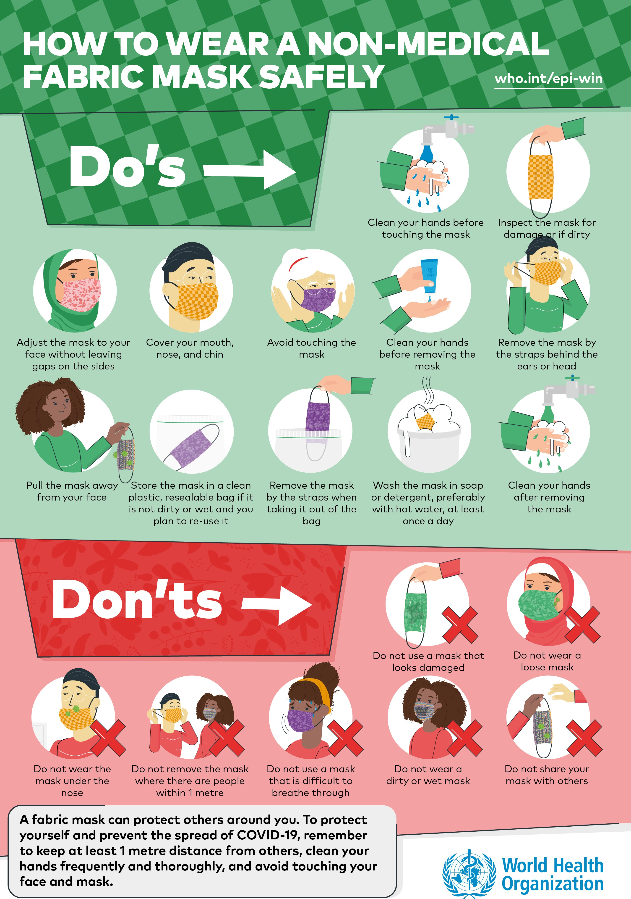EPI-WIN tranlsates WHO’s technical guidance into simple messages for the public.

## Scaling up country readiness and response: the comparative advantage of WHO’s regional structure

International coordination and support is essential because it underpins and enables the work of national governments, WHO and partners at regional and national level to support preparedness and response operations at community level.

This is how we will ultimately control the pandemic: working with all of government and all of society in every society to stop

transmission in our communities. The SPRP and the Operational Planning Guidelines to Support Country Preparedness and Response set out the key pillars of response at regional, national and subnational level:

* Country-level coordination, planning, and monitoring;
* Risk communication and community engagement;
* Surveillance, rapid-response teams, and case investigation;
* Points of entry;
* National laboratories;
* Infection prevention and control;
* Case management;
* Operations support and logistics;
* Maintaining essential health services and systems.

The previous section detailed the work at a global level that has strengthened these pillars at the national level. But equally important has been the role of the WHO Regional Offices and

regional partnerships platforms, which have been able to deliver vital targeted support in areas where there has been no other source of help.

One of the primary vehicles for supporting countries from the regional level has been the deployment of technical and partner support missions. These missions enable experts from WHO and partners to deliver targeted and tailored technical guidance on a range of issues including laboratory support, disease surveillance, operational planning, points of entry support, hospital preparedness, and infection prevention and control.

Despite the ongoing travel restrictions and disruption, WHO Regional Offices have continued to deploy experts to support countries in situ wherever safe and feasible. Where it has not been possible to make direct deployments, Regional Offices have implemented innovative digital solutions such as webinars and remote working to overcome the challenges posed by travel restrictions (table 6).

Regional platforms have also been an essential support-delivery tool as the pandemic has progressed.

In the African region alone, the WHO Regional Office has coordinated with platforms including the health agencies from the regional economic community such as the West African Health Organization and the East African Community

**Table** **6** Overview of COVID-19 support missions from WHO

Regional Offices up to 30 June 2020

|  |  |  |
| --- | --- | --- |
| **WHO** **Region** | **Number** **of** **countries** **hosting** **missions** | **Number** **of** **missions** |
| **Africa** | 18 | 42 |
| **Eastern** **Mediterranean** | 22* | 22* |
| **Europe** | 20 | 74 |
| **South-East** **Asia** | 11* | 40* |
| **Americas** | 20 | 25 |
| **Western Pacific** | 37* | 149* |
| **Total** | **128** | **352** |

*Includes dedicated remote support.

which are collaborating with WHO hubs; health networks such as the West African Network for Tuberculosis, Aids, Malaria and NTDs (WANETAM), Network of National Public Health

Institute of Lusophone speaking countries (RINSP), African Field Epidemiology Network (AFENET), and International Association of National Public Health Institutes (IANPHI).

In the European region, WHO has developed a series of Regional Platforms with key partners and networks to facilitate the alignment of COVID-19 guidance across the Region, and expand WHO’s preparedness and response activities. The GOARN and the WHO Emergency Medical Teams (EMTs) initiative have both played key roles in providing operational and technical support to countries. Professional networks of experts in respiratory pathogens including the European Influenza surveillance network have also been leveraged to support countries. WHO works side by side with the European Centre for Disease Prevention and Control (ECDC), regional networks and national counterparts, to update and enhance surveillance strategies. The work carried out extends to all countries across the Region, including EU and non-EU member states.

In the Americas, WHO/PAHO’s Regional Database on Health Technology Assessments (HTA, or BRISA according to its Spanish acronym) has provided health authorities from across the Americas with guidance on medical devices and other health equipment critical to providing care for COVID-19 patients. At the end of June 2020, 44 HTA reports were available on items related to COVID-19, and web visits have jumped by 184% compared to the same period last year. WHO/PAHO also launched the COVID-19 Evidence Portal to serve as a space for resources from across the Americas to be made available to the public. Classified by their relevance for saving lives, protecting health care workers, and slowing spread, users have access to 1449 documents in English, Spanish, and Portuguese.

Further details of WHO’s work with regional platforms and

partners are provided below.

### Country-level coordination, planning, and monitoring

A public health emergency on the scale of COVID-19 will test the resilience of nations, businesses, and communities. In national risk management, the government is the natural leader for overall coordination and communication. These efforts are supported by WHO and other UN organizations, and through the Cluster-coordination approach. Every WHO regional office and country office has activated a COVID-19 incident management

planning and coordination. Across all regions there has been a marked improvement in planning and coordination capacity between 1 March and 30 June. The proportion of Member

States in all regions with a preparedness and response plan has increased from 46% to 83% over the period, with an increase from 45% to 92% in the proportion of Member States with a functional COVID-19 coordination mechanism. The target for both indicators is 100%.

### Monitoring progress

##### Proportion of countries and territories with a COVID-19 preparedness and response plan (target: 100%)

**46%**

**83%**

A plan explains the strategy to prepare and respond across all sectors of government and society. Evidence of a plan can include a framework of response for national and subnational authorities. WHO provides Operational planning guidelines to support country preparedness and response.

#### At 1 March

At 30 June

structure to provide operational and technical support to national governments in all aspects of readiness and response, including

##### European region

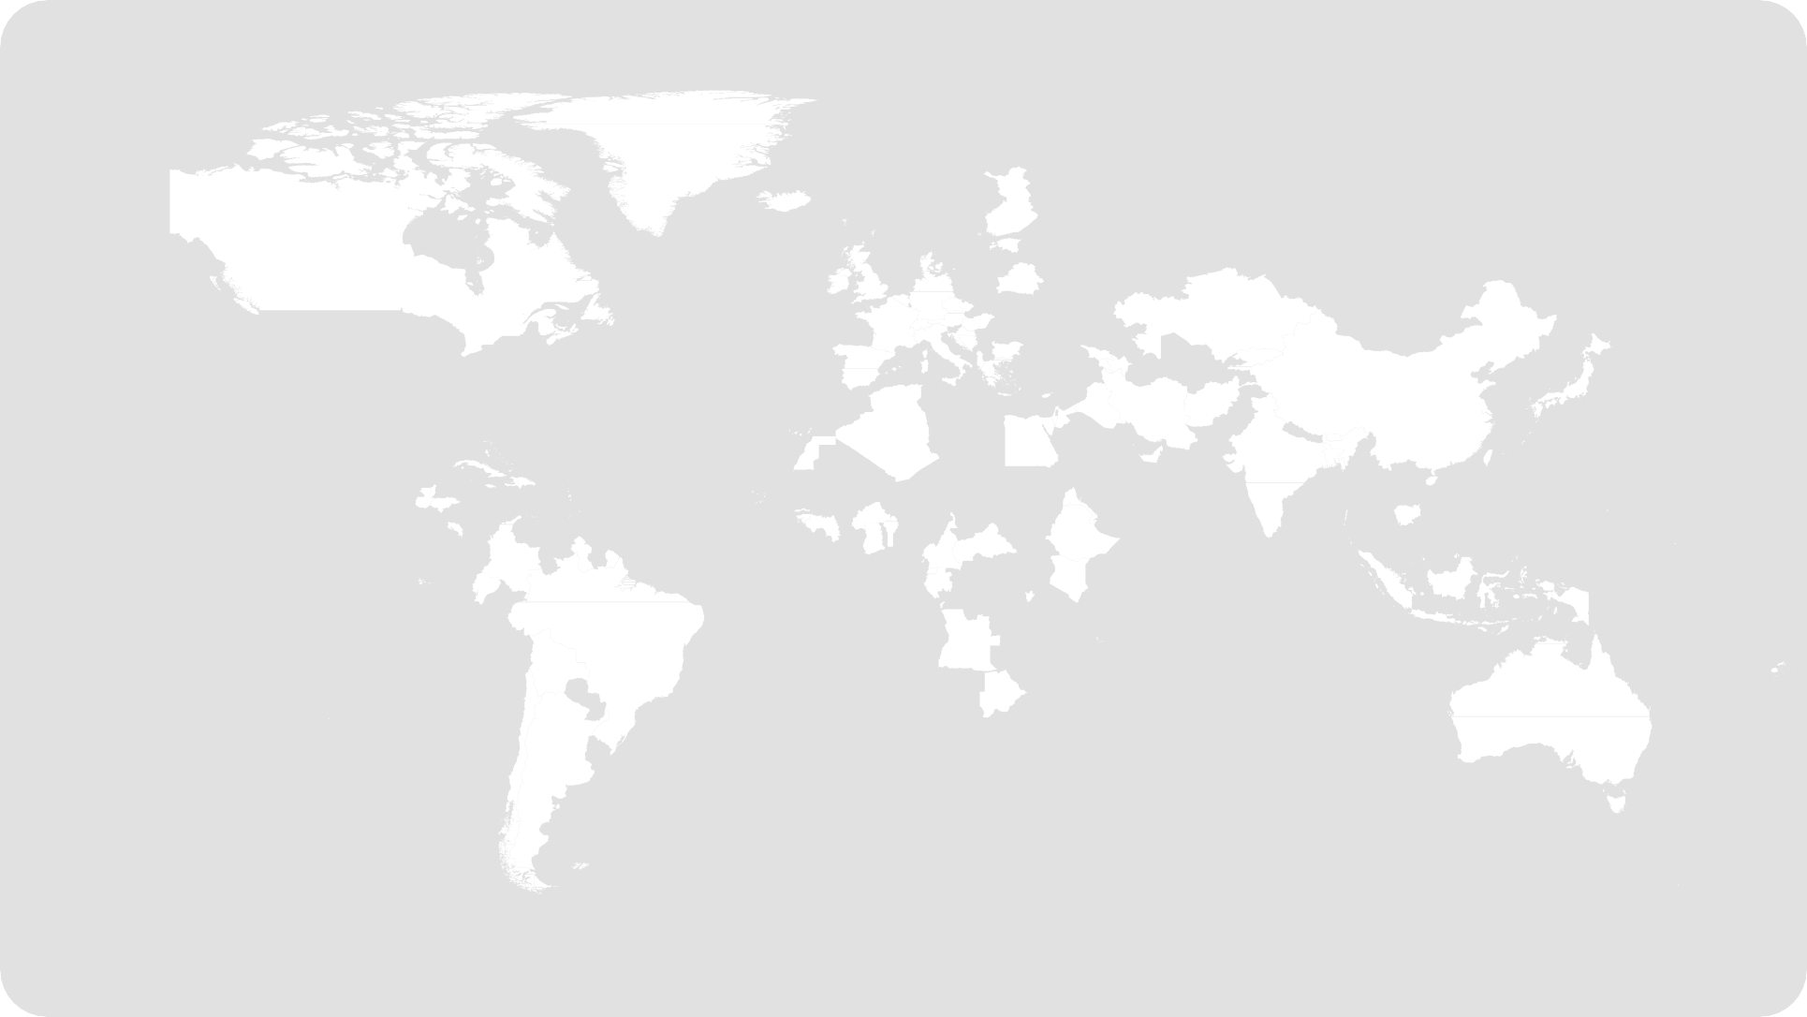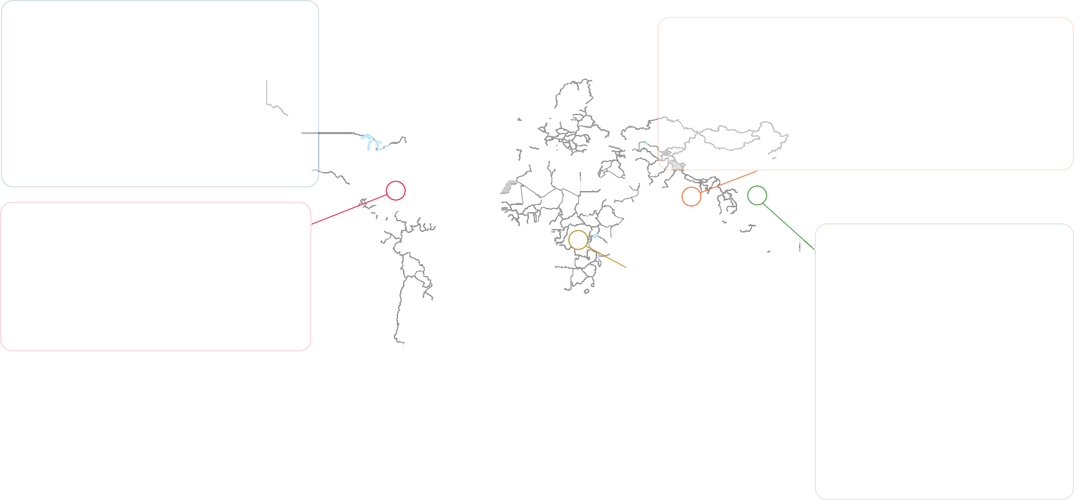

The WHO Regional Office for Europe activated its Incident Management Support Team (IMST) in accordance with WHO’s Emergency Response Framework (ERF) on 23 January 2020, to respond to the increased risk assessed at the global level. Through the WHE Hubs and Country Office teams, the WHO Regional Office for Europe is providing direct support to countries in coordination with UN Country Teams (UNCTs) and operational partners. The Regional IMST has remained

agile to meet different country needs, and organized itself around several key response pillars, with public health and health systems readiness at the centre. Capturing information from countries has been supplemented by the COVID-19 Health System Response Monitor (HSRM)—a new online platform providing countries and stakeholders in the WHO European Region with evidence of how national health systems are responding to the COVID-19 pandemic. In April 2020, a Special Projects Group (SPG) was established within the regional IMST, to work on specific topics related to COVID-19 (e.g. vulnerable populations, vaccine deployment, research and development) and laying the ground for medium-term strategic interventions.

##### Proportion of countries and territories with a functional COVID-19 coordination mechanism (target: 100%)

**45%**

**92%**

Functional in this context means that the mechanism has the key components outlined in the Framework for a Public Health Emergency Operations Centre, including plans/procedures, physical infrastructure, information systems and standards, and human resources.

##### South-East Asia region

In early January, the Regional Office set up the Regional Incident Management Support Team (IMST) to cover all critical functions in line with WHO’s Emergency Response Framework, and communicate with countries for effective coordination. Technical experts from all departments within the Region Office were involved in the IMST to ensure guidance was provided to countries across all pillars. The Regional Office has provided technical guidance and support to the WHO country offices and the ministries of health through virtual one-to-one meetings having their preparedness and response capacities assessed and identifying the gaps. The Incident Management System at each country level was activated. Regular IMST meetings were convened to monitor the evolving situation and effectively and efficiently guide WHO’s response in the Region. With many regional offices of UN agencies and partners being located in Bangkok, Thailand, a liaison mechanism with support from WHO Country Office for Thailand was establish to represent WHO at the ad hoc Working Group for the COVID-19 response. The Regional office also regularly engages in deep-dive calls with WCOs to discuss in-depth epidemiological analysis, transmission scenarios and strategic priorities across the nine pillars.

##### Region of the Americas

The first case of COVID-19 in the Americas was confirmed in the USA on 20 January 2020, followed by Brazil on 26 February 2020. Since then, COVID-19 has spread to all 54 countries and territories in the Americas, which is currently considered one of the globe’s major epicenters. PAHO/WHO activated regional and country incident management system teams to provide direct emergency planning and response support to Ministries of Health and other national authorities for surveillance, laboratory capacity, support health care services, infection prevention control, clinical management and risk communication. By the end of April, 32 of 35 countries had COVID-19 preparedness and response plans and the Region of the Americas maintained the leadership position in use of the COVID-19 Partners Platform, with 90% of countries engaging and 86% of countries using the Platform.

##### Eastern Mediterranean region

Multidisciplinary technical teams from WHO, GOARN partners and other experts were deployed to Afghanistan, Bahrain, Egypt, The State of Kuwait, Iraq, The Islamic Republic of Iran and Pakistan to support and assess ongoing COVID-19 readiness and response efforts. The missions improved understanding of the current situation; reviewed ongoing response activities; provided on-site technical support as needed; and identified strengths and gaps to guide response priorities. WHO experts continue to work closely with national emergency incident management systems, and in some countries serving as WHO focal point/Incident Managers for the response.

##### African region

Emergency partner coordination meetings convened in February in Nairobi and Dakar triggered the development of a joint regional partners’ preparedness and response plan

covering all countries in the WHO African region. Priority actions by interventional pillar have been agreed, and a coordination mechanism has been fully operationalized, with coordination hubs established by WHO in both Dakar and Nairobi in March 2020. At the level of the Regional Office in Brazzaville, WHO’s leadership and coordination role is ensured by means of

weekly coordination meetings with health partners, including Emergency Medical Teams and the African Partner Outbreak Alliance (APORA) and the deans of African university medical faculties. In addition, bi-weekly regional coordination meetings are organized with key donor stakeholders. National Action Plans using the operational planning guidelines provided in line with the SPRP have been finalized, technical guidance disseminated and tailored to the Member States, and existing capacities and critical gaps at the country level have been

re-assessed and mapped to allow for targeted response and support.

##### Western Pacific region

WHO together with humanitarian and development partners have established a joint Incident Management Team (IMT) to support COVID-19 preparedness and response efforts in the Pacific. This coordination mechanism has successfully leveraged partners’ capacities and resources, and continues to coordinate their actions to ensure that effective support is

provided to national authorities and affected populations. Since January 2020, the joint IMT has developed and is implementing a Pacific Action Plan for COVID-19 preparedness and response based on the nine pillars of the WHO Operational Planning Guidelines to Support Country Preparedness and Response.

In May 2020, the joint IMT endorsed the Phase 2 Health Sector Support Plan, signalling a shift in the operational support model for the Pacific to containment and mitigation. Recognizing the importance of a multi-sectoral and all-of-society approach to the COVID-19 response, the joint IMT collaborates closely

with health sector partners, as well as with partners from other clusters through the Pacific Humanitarian Team regional cluster system. With support from OCHA, all Pacific clusters are now operational in support of COVID-19 preparedness and response. Through regular coordination, the IMT has

enabled rapid action in the Pacific, with Pacific Island Countries and areas (PICs) supported to strengthen their COVID-19 preparedness and response.

### Risk communication and community engagement

Slowing the transmission of COVID-19 and protecting communities will require the participation of every member of at-risk and affected communities to prevent infection and transmission. This requires everyone adopting individual

protection measures such as washing hands, avoiding touching their face, practicing good respiratory etiquette, individual level distancing and cooperating with physical distancing measures and movement restrictions when called on to do so. It is therefore essential that international, national, and local authorities engage through participatory two-way communication efforts proactively, regularly, transparently and unambiguously with all affected and at-risk populations.

and influencers to promote scientific and public health messages

will be a key determinant of the effectiveness of the response. Building the capacity of national, regional, and local stakeholders is essential to establish authority and trust. The role women play in communities needs to be harnessed in community mobilization efforts. Participatory community engagement interventions should include accurate information on risks, what is still unknown, what is being done to find answers, what actions are being taken by health authorities, and what actions people can take to protect themselves. WHO has tracked an improvement from 1 March

to 30 June in the proportion of countries and territories that have communicated COVID-19 prevention and preparedness messages to the population, which rose to 99%. The proportion of countries and territories that have a community engagement plan rose from 19% to 85% over the same period. Examples of

### Monitoring progress

##### Proportion of countries and territories that have communicated COVID-19 prevention and preparedness messages to the population (target: 100%)

**43%**

**99%**

Prevention messages include actions for individuals to protect themselves, such as hand hygiene.

##### Proportion of countries and territories that have a COVID-19 community engagement plan (target: 100%)

**19%**

**85%**

A community engagement plan should include at least four of

Understanding knowledge, behaviours, perceptions, and identifying the right channels and community-based networks

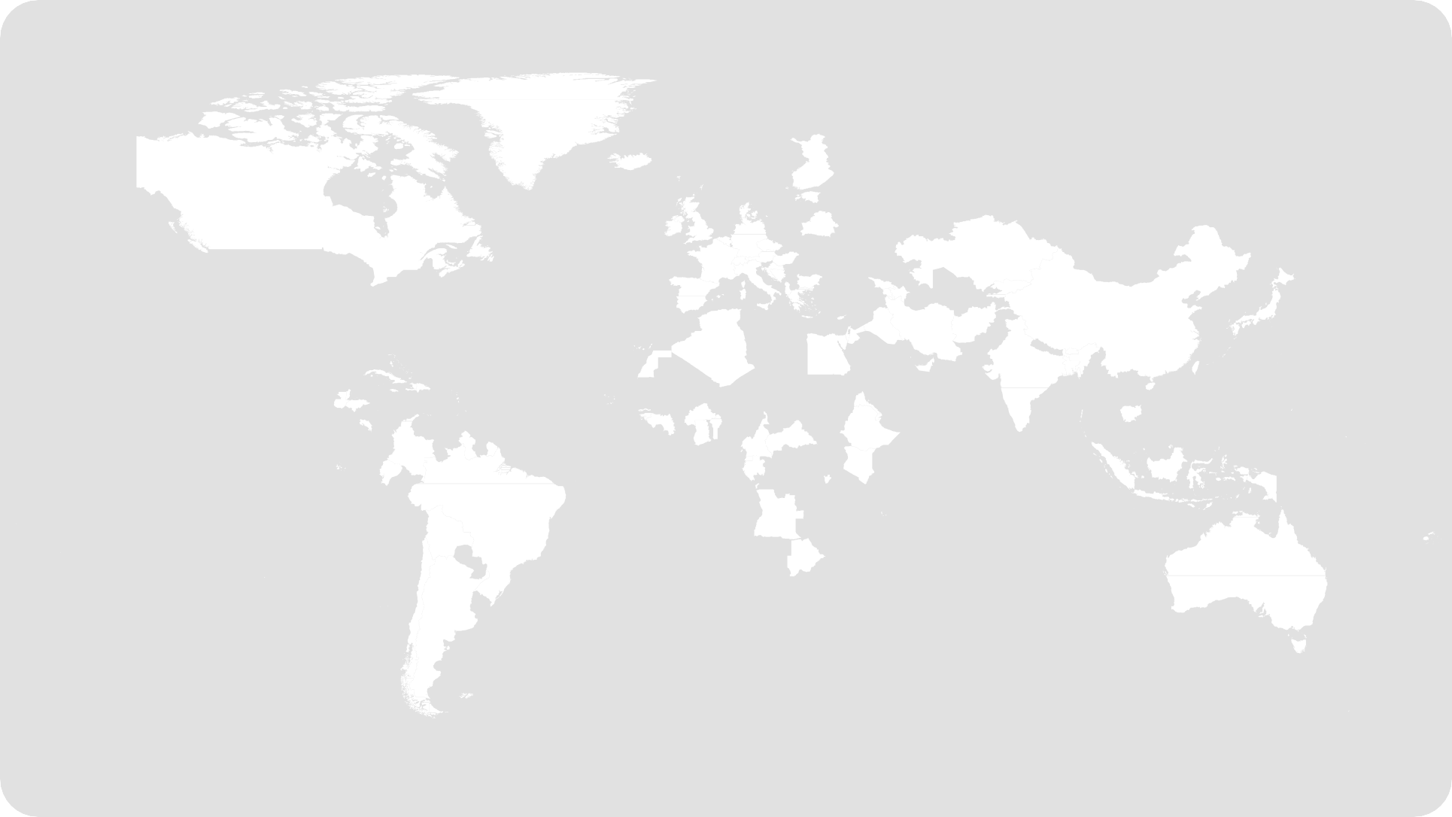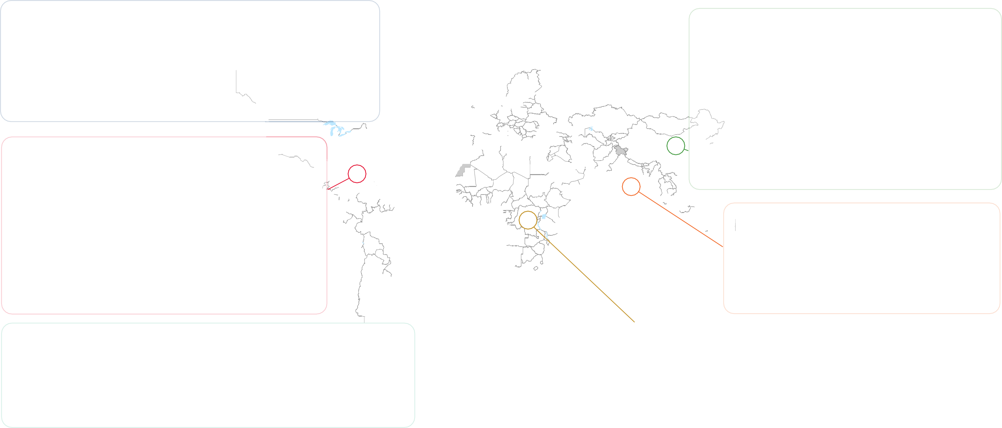

##### European region

specific targeted WHO support for countries within each region

are given below.

the six recommended actions outlined in the SPRP.

**Western Pacific region**

#### At 1 March

At 30 June

Understanding public levels of trust, people’s perceptions of risk, and the barriers they may face in

following recommended actions is critical to the effectiveness and success of pandemic response measures. WHO/Europe has leveraged innovative solutions for risk communication and community engagement (RCCE) to support countries. On 03 April 2020, WHO/Europe launched a supplement to the broader RCCE strategy in the context of COVID-19, focused on RCCE in the Transition Phase for National Health Authorities. This template, meant to be tailored to the country context, covers the role of RCCE and key actions needed to support countries as they adjust public health and social measures and ensure that individuals adopt protective behaviours which contribute to the control of the COVID-19 pandemic nationally and globally. So far, 17 of 25 priority countries have finalized or are developing a RCCE strategy.

##### Region of the Americas

In order to address the need for clear, consistent, and authoritative information, the region has created a detailed risk communication package for healthcare facilities, guidelines for communicating about COVID-19 for leaders, advice for journalists, and a comprehensive planning template for risk communication and community engagement. In addition, the regional website has a range of resources to share through social media. PAHO’s social media platforms are being used to reach targeted audiences through media briefings, “Ask the Expert” sessions, and media cards. PAHO has also collaborated with Colombian singer Salomón Beda in an agreement under which the artist donates the royalties of his musical theme “Pa’alante” to activities that PAHO is implementing to combat COVID-19. Artists from Argentina, Colombia, Peru, Mexico, Ecuador, Venezuela, Chile, Puerto Rico, and the United States joined forces to record a new version of the song under an initiative called #Volveranlosabrazos (The hugs

will return). The artists will also collaborate in spreading information about the disease among their followers. PAHO has supported national risk communicators in Colombia, Peru and Suriname to make available COVID-19 key messages in indigenous languages.

Working with partners such as the IFRC and its national societies and other UN agencies allows WHO to conduct thorough assessments of the general public’s understanding of COVID-19. This knowledge has been successfully leveraged to strategically adapt risk communications messages and products based on the

current needs of the population. A regional risk communications plan has also been developed, and includes products and materials that can be adapted for country use. For example, in Lao PDR, social media, and in particular Facebook, is the most important source of news and information for most Lao people. WHO’s key platform for reaching people on the COVID-19 response is the Facebook page of

the Ministry of Health’s Centre for Communication and Education for Health (CCEH). This has gone from having about 3000 followers at the end of 2019 to nearly 174 000 as of 26 June. Webcasts by the CCEH team, with technical support on content

from WHO, typically get between 25 000 and 100 000 views. In April, at the height of the first COVID-19 outbreak, over 300 000 tuned in and webcasts took place daily. Additionally, short messages on COVID-19 and how individuals can protect themselves are sent regularly to 3 million mobile phone users across the country.

##### South-East Asia region

The Regional Office developed a Regional Risk Communication Strategy that met the needs of Member States. In addition, an Interagency Asia- Pacific Risk Communication and Community Engagement Working Group was set up to develop guidelines specific to vulnerable populations.

WHO is a partner in the Working Group’s Asia-Pacific-wide perception survey. For awareness, a “whole-of-society” approach was followed, with a “It’s On Us to Win the Fight Against #COVID19” campaign. Over 200 animated images (e.g. gif and video formats) in 11 languages, and infographics for key audiences, have been developed and disseminated.

##### Eastern Mediterranean region

At the regional level, an Interagency Risk Communication and Community Engagement working group consisting of 12 partners was established to provide strategic guidance to countries, including on safe Ramadan practices in the context of COVID-19. Mapping of national risk communication plans was completed and produced a rapid training module on RCCE for WHO communications officers. Twelve countries have also been identified for ongoing technical support in a joint collaboration with UNICEF. EMRO also worked with the Islamic Advisory Group (IAG) and a WHO collaborating centre in Saudi Arabia on the development of faith- based messaging. The Regional Director also contacted the Grand Imam of Al Azhar and Executive Committee of Islamic Advisory Group to support the COVID-19 response.

##### African region

WHO is helping local authorities across the region craft radio messaging and TV spots to inform the public about the risks of COVID-19 and what measures should be taken. The Organization is also helping to counter disinformation and is guiding countries on setting up call centers to ensure the public is informed. The Regional Office website has a wide range of online resources for use with social media, including social media cards for Facebook and Twitter, and YouTube, with simple, clear messages on how individuals can protect themselves and others from COVID-19.

### Surveillance, rapid-response teams and case investigation, and national laboratories

Stopping the spread of COVID-19 requires finding and testing all suspected cases so that confirmed cases are promptly and effectively isolated and receive appropriate care, and the close contacts of all confirmed cases are rapidly identified so that they can be quarantined and medically monitored for the

14-day incubation period of the virus. To achieve this, countries

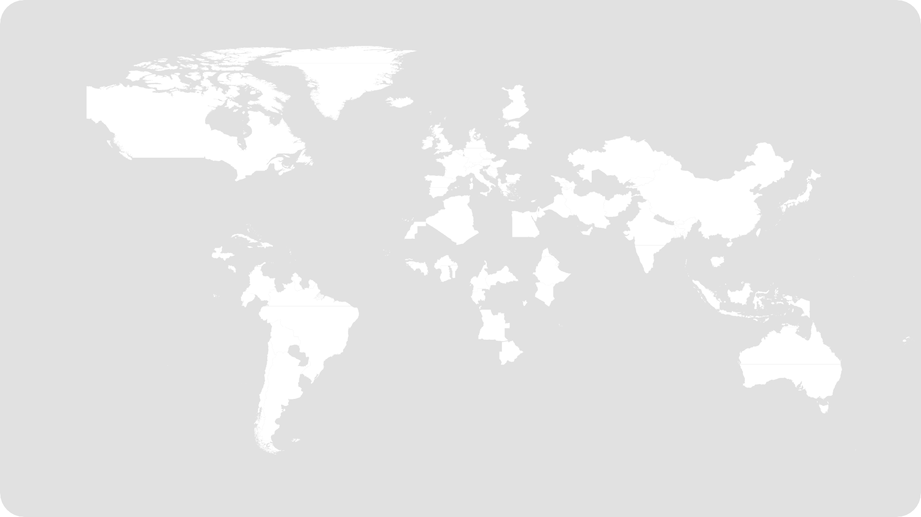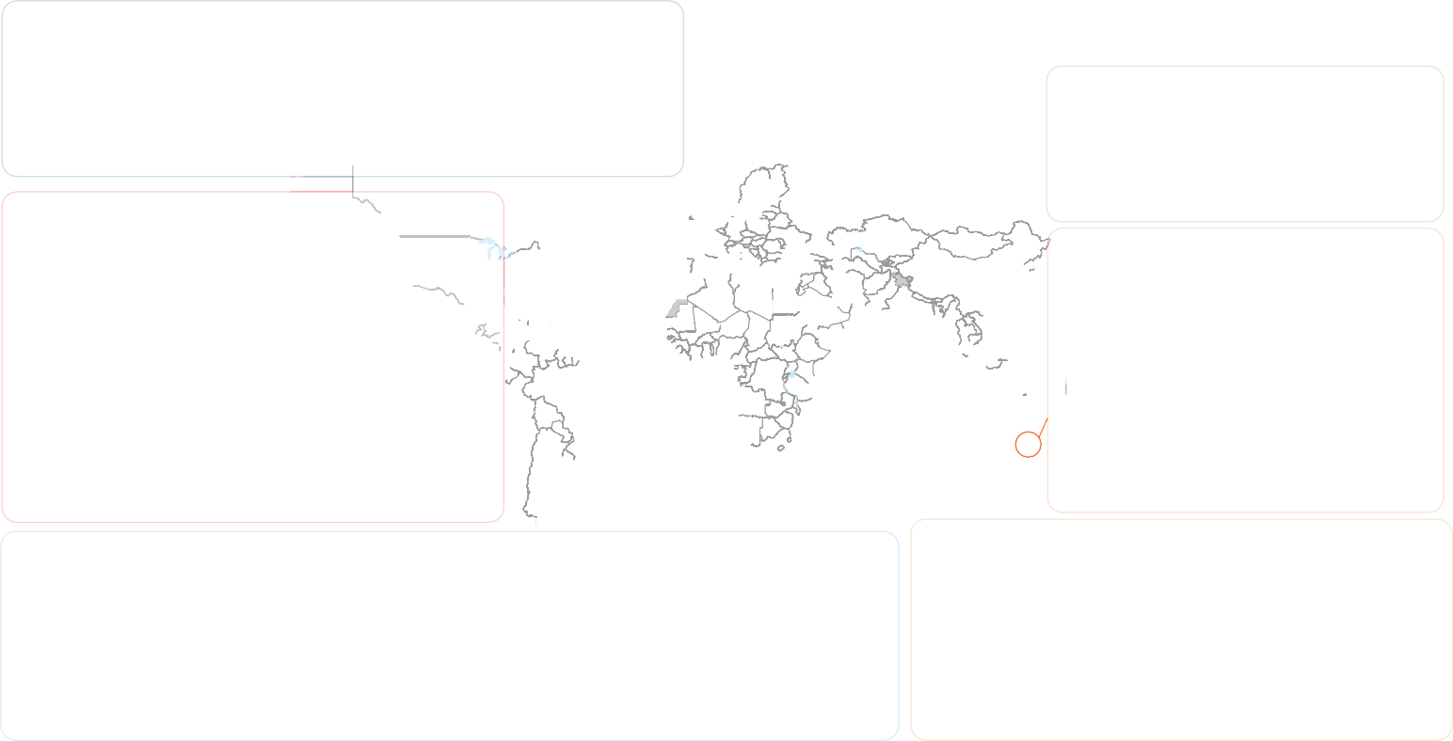

##### European region

and communities must fundamentally increase their capacity to identify suspected cases of COVID-19 in the general population quickly based on the onset of signs or symptoms. WHO has worked closely with national authorities to ensure that all countries have access to diagnostic testing as part of surveillance strategies based on WHO guidance. By the end of June, 99% of countries and territories had the ability to conduct COVID-19 testing, or had established access to an international laboratory within 72 hours. The target for this indicator is 100%.

### Monitoring progress

##### Proportion of countries and territories that have access to laboratory testing capacity (target: 100%)

**85%**

**99%**

Laboratory testing capacity is defined as either in-country laboratory testing capacity, or access to international

laboratories that can provide results within 72 hours.

#### At 1 March

At 30 June

WHO works closely with the ECDC, using its existing shared networks on surveillance to engage all European Member States in sharing surveillance strategies, challenges, and experiences with specific investigations (e.g. schools, food processing facilities). **Direct** **technical** **support** **has** **also** **been** **provided** **to** **a** **total** **of** **10** **countries** **within** **the** **Region** **on** **conducting** **sero-** **epidemiology** **surveys**. On contact tracing, WHO is working to support countries across several areas, including sharing country- specific models across the region, calculating workforce requirements, providing guidance on digital contact tracing, and engaging communities. **WHO has established five regional reference laboratories to support international testing where countries have** **limited** **capacity.** WHO is providing direct remote and in-country support across the region, including to Tajikistan, where capacities are being assessed and strengthened in five laboratories in Dushanbe, and other regional labs. Remote country support has been scaled up through various training activities, country calls, consultations with national partners and weekly laboratory workshops. **Laboratory** **testing** **kits** **and** **supplies** **have** **been** **distributed** **to** **32** **countries** **in** **the** **region.** WHO has enhanced countries’ testing capacity through coordination of quality assurance for the detection of COVID-19.

##### Region of the Americas

At the outset of the outbreak in the subregion of Eastern Caribbean, PAHO/WHO was the only international partner able to provide COVID-19 test kits to the islands. This was instrumental in preparing the islands to quickly test potential cases and thus minimize the spread of the virus. Thanks to PAHO/WHO support, technicians in all ten islands were trained in COVID-19 diagnostics in February, strengthening their capacity to detect COVID-19.

Laboratory capacities within the region were strengthened to address the COVID-19 pandemic. At the outset of the outbreak, and before travel restrictions were implemented, PAHO/WHO deployed experts to nine countries to implement laboratory strengthening and training. The remaining countries participated in two subregional trainings and subsequently virtual sessions. **By** **mid-February,** **capacity** **for** **molecular** **SARS-CoV-2** **testing** **was** **successfully** **implemented** **in** **all** **35** **Member** **States**. This, coupled with the primers, probes and approximately 4.9 million PCR kits distributed in the region has enhanced the laboratories’ capacities for early detection.

In addition, PAHO/WHO is currently implementing its “COVID-19 Genomic Surveillance Regional Network Project”, whereby **16** **countries** **are** **being** **supported** **to** **generate** **sequences** and report more timely data to GISAID. Previously only three countries (Chile, Brazil, Mexico) had been uploading sequences. To date, Argentina, Canada, Colombia, Costa Rica, Ecuador, Jamaica, Peru, Panama, the United States of America, and Uruguay have also begun to upload sequences. Surveillance was further enhanced with the launch of the COVID-19 Information System for the Region of the Americas, produced through collaboration with ESRI. This real-time information has been crucial in supporting countries with their preparation and response.

##### African region

##### Western Pacific region

WHO and the joint IMT are working to ensure all Pacific Island Countries (PICs) have a basic package of supplies and appropriate guidance for specimen collection, transport, packaging and shipping. Together, they have **facilitated** **testing** **capabilities** **for** **COVID-19** **being** **established** **in** **14** **PICs** **using** **RT-PCR** **and** **GeneXpert** **testing** **platforms**. This is in

addition to support provided to map referral pathways and requirements for sample collection, transport and testing with five laboratories in the region. In addition, WHO has conducted a series of trainings on Go.Data in Viet Nam (see above) with support from GOARN partners.

##### South-East Asia region

In early February the Regional Office provided potential transmission scenarios and guidance to develop national standard operating procedures for **early** **detection** **and** **contact** **tracing** **using** **Go.Data**. A Regional Surveillance Strategy, complementing the WHO global surveillance guidance, was provided to Member States. Internal risk assessments (country profiles) have been conducted to monitor transmission dynamics and epidemic trends and to guide the response. An online case reporting form had been developed and South-East Asia regional dashboard was made available to the public. Technical support was further strengthened by a series of country-level and regional technical webinars, involving the country offices and the ministries of health and other relevant departments. In early February, **two** **global** **reference** **laboratories** **were** **established** **in the Region, and testing capacity was enhanced for the Region’s**

**11** **Member** **States** in March. Ten of the 11 countries in the Region have expressed their willingness to participate in the global External Quality Assurance Programme (EQAP) for national laboratories coordinated by WHO. With the first shipment of EQAP panels, **six** **Member** **States** **have** **successfully received and completed the EQAP**.

##### Eastern Mediterranean region

Surveillance activities have been enhanced for most EMR countries. As a result, as of mid-April, **77%** **of** **EMR** **countries** **now** **have** **COVID-19** **event-based** **surveillance.** **All** **22** **countries** **of** **the** **region** **have** **trained** **multidisciplinary** rapid response teams, and all countries have activated and deployed rapid-response teams to support case management and provided technical training, and, where relevant, equipped to investigate suspected cases in line with protocols.

Efforts have been accelerated across the region to prepare laboratories and establish and sustain laboratory confirmatory capacity, including the organization of a remote training covering testing for COVID-19, including molecular testing, serology, and rapid diagnostic tests, facilitated by EMRO, for the EMR COVID-19 Laboratory Network

and **attended** **by** **45** **participants** **from** **18** **countries**. Adequate test kits and other essential lab consumables were procured and prepositioned in Dubai, and most of the

priority countries in the region received these laboratory supplies on time.

In addition, EMRO enhanced countries’ testing capacity through training and the coordination of the WHO external quality assessment programme (EQAP) for the detection of COVID-19. **All** **countries** **have** **the** **capacity** **to** **test** **COVID-19** **virus** **by** **polymerase** **chain** **reaction** **(PCR)**; the remaining two countries are connected to international referral networks. EMRO continues to support the COVID-19 laboratory network with PCR troubleshooting, and led on a number of regional initiatives including the shipment of specimens of COVID -19 for sequencing and further analysis, the provision of technical assistance to the regional COVID-19 lab network on the assessment of their performance and quality of the test(s) donated by other organizations, and ensured coordination with laboratories in Geneva and France to provide support to the occupied Palestinian territory, Iraq, Yemen, Jordan, Lebanon and The Syrian Arab Republic.

Since the start of the outbreak WHO has been supporting African governments with early detection of COVID-19 by delivering **one** **million** **test** **kits**. An additional two million are under preparation to send to countries, and WHO is also supporting the training of laboratory workers. By late June, **all** **47** **countries** **in** **the** **WHO** **African** **region** **had** **capacity** **to** **conduct** **molecular** **testing** **for** **COVID-19**. One-on-one technical support has been provided to almost every country in the region, and a small subset of countries (Botswana, Chad, Comoros, Equatorial Guinea, Ethiopia, Mauritania, Rwanda,

Sao Tome and Principe, Tanzania and Zimbabwe) have benefited from having onsite technical support

before travel restrictions were put in place. Laboratory capacity is rapidly being built in countries at a sub-national level, mobilizing already existing platforms that are available for testing and providing

additional platforms and building human resource capacity where needed. Over the coming weeks **over** **52 laboratories from 43 countries in the region have received the first round of the EQA material to** **ensure** **that** **quality** **data** **is** **generated** at the national and regional levels. Surge procurement and distribution of essential reagents and supplies have been initiated to provide urgently needed critical items to countries for testing for COVID-19, and to build capacity in countries.

WHO provides a weekly donor briefing to groups of more than 50 donors and partners, and has now met with ambassadors from over 25 different countries to brief them on the situation and the country’s needs. To leverage the collective efforts

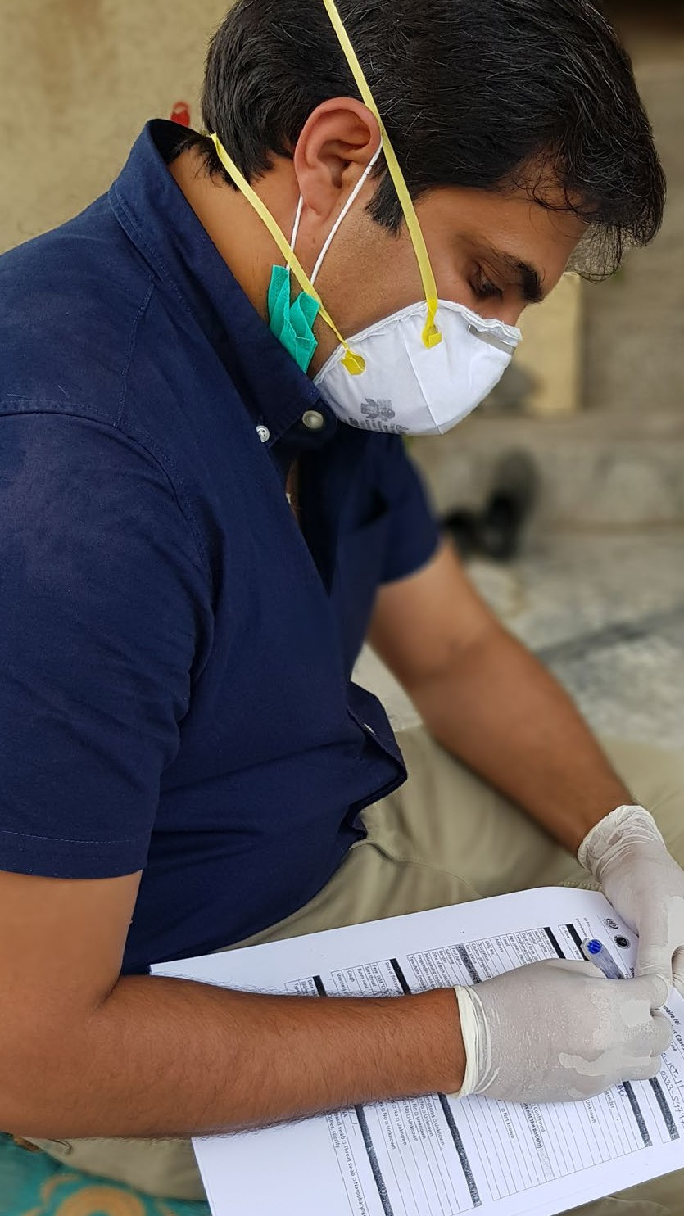

Credit: WHO

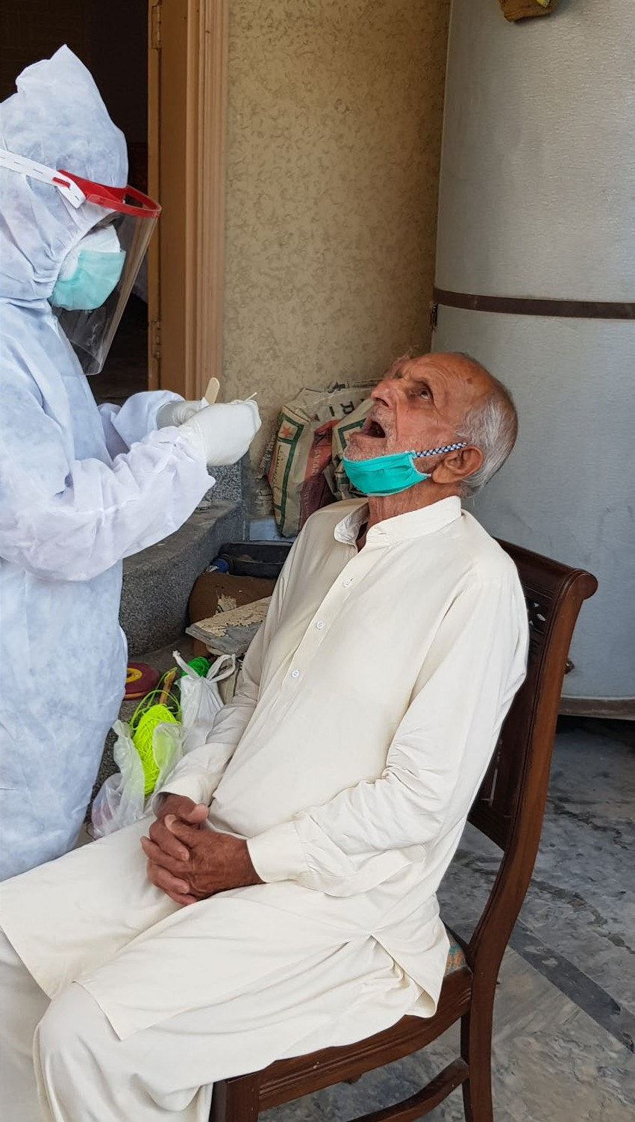

Credit: WHO

of the UN, WHO leads a weekly Crisis Management Team meeting comprising of the UN Resident Coordinator and key UN Agencies supporting the response.

As the key technical partner, WHO has helped to establish and continues to participate in all technical working groups in the country, tackling all the key issues, including isolation of confirmed cases, case management, testing. To ensure the ready adaptation of global guidance to the national situation and context, WHO has also assembled a Think Tank of diaspora and locally based Pakistani public health experts to regularly meet and advise the Government and partners on various aspects of the response. A mission of WHO experts from the Eastern Mediterranean region travelled to the country to conduct an assessment and provide recommendations, and continue to provide daily technical back-up to WHO’s country office staff.

WHO has also been active at the operational level, and was initially the sole provider of personal protective equipment in the early stages of the outbreak. WHO also provided thermo-guns for screening at points of entry, including all major airports, and set up COVID-19 information desks in three major airports. WHO has also leveraged the existing

polio surveillance network. The polio team has been actively supporting disease surveillance, outbreak investigation, contact tracing and awareness raising campaigns. Polio

reference laboratories in the countries are providing support for COVID-19 testing, and also training laboratory technicians at new testing sites.

With US$1.4 million funding from GAVI, the vaccine alliance, WHO has established a dedicated Infection Prevention and Control (IPC) team and undertaken assessment of 200 priority hospital facilities to advise them on improvement measures in readiness for COVID-19. Procurement of supplies to enhance IPC is also underway, and to date more than 1500 Health Workers have undertaken WHO’s virtual IPC training.

To increase testing capacity, WHO procured and distributed 15 PCR machines for point of care testing, and has provided technical assistance to leverage the country’s impressive tuberculosis treatment infrastructure across the country to enhance testing by a further 2000 tests per day. Tuberculosis centres are being equipped with N95 masks and other PPE to protect frontline workers. Centres are using couriers to deliver 3-months’ supply of medicines to patients to ensure that the country’s already vulnerable and immunosuppressed tuberculosis and HIV patients are protected.

WHO is supporting Pakistan to maintain essential services, and has developed and disseminated guidance and recommendations for different clinical settings, supported the establishment of toll-free numbers, and bolstered ambulance services. Under the SPRP, WHO is working with the government to innovate and harness technology to reach people with essential services during this time – for instance, telemedicine is being introduced in 100 hospitals.

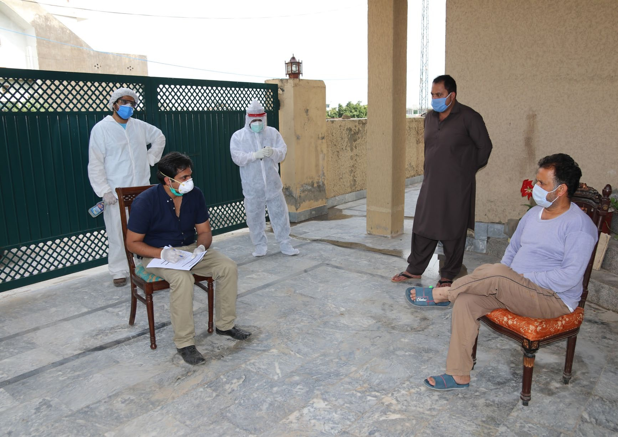

Credit: WHO

#### **In** **Focus:** From pillar to pillar in Pakistan

Since early January, WHO has been working closely with the Ministry of National Health Services, Regulation and Coordination (MNHSR&C) and all line ministries in Pakistan at both federal and regional level to contain and mitigate the impacts of COVID-19 outbreak in the country. The response to COVID-19 started before the first case was detected, with

WHO briefing Government officials, the donor community and partners, and provided technical guidance on preparedness and response to COVID-19.

Pakistan, with a population of over 221 million, is the 5th most populous country in the world. The outbreak of COVID-19 presents a potentially devastating threat. To call attention to this threat WHO supported some of the earliest modelling

of possible COVID-19 transmission in the country. In collaboration with the National Health Services Academy and the London School of Hygiene and Tropical Medicine, WHO produced predictions for the country’s potential case load.

As of 30 June the virus has spread throughout the country, with more than 200 000 confirmed cases and more than 5000 deaths. Over 150 districts are affected. The two hardest hit provinces are Punjab and Sindh.

Based on these predictions, the Pakistan Preparedness and Response plan was developed by the government with technical support from WHO. The total cost of the plan is

US$595 million. The World Bank and the Asian Development Bank have each provided US$200 million, and other donors have pledged to contribute. On 23 April, the WHO Director- General attended the official launching of the country’s preparedness and response plan.

To support the coordination of the national response and operationalization of the national plan, WHO supported the establishment of an operational cell, chaired by the Ministry of Health, in January, and ensured a Strategic Health Operations Centre was set up and maintained to monitor the situation across all provinces and provide rapid support. More recently, WHO has provided equipment and supported the establishment of a Situation Room at the Ministry of National Health Services Regulation and Coordination. This will serve as a platform for acquiring online data, which will help ensure a robust response to COVID-19 cases.

To enhance the coordination of efforts among the large number of international partners and donors in Pakistan,

Clockwise from opposite: Dr M Zeeshan, frontline health worker, and Dr Taimoor Hafiz Janjua, COVID-19 Surveillance Officer from the Pakistan Department

of Health,, collect samples and take a detailed history of a patient with confirmed COVID19 and his close contacts in Islamabad. WHO regional and country office staff have provided

technical support, laboratory equipment, essential supplies of PPE, and operational assitance at points of entry.

### Infection prevention and control, case management, and continuity of essential health services

Even very robust health systems can be rapidly overwhelmed and compromised by an explosive COVID-19 outbreak. In addition to the direct mortality caused by COVID-19, response at the national and subnational level must also address the risks of indirect

strategies, physical distancing and movement restrictions, must be mitigated in order to minimize the negative health impacts of

COVID-19 on individuals who depend on essential, non-COVID-19- related services. WHO is working across regions to strengthen capacity for infection prevention and control, guide and support optimum case management, and help authorities to maintain essential health services. WHO documented an increase from 37% to 75% from March to the end of June in the proportion of countries

### Monitoring progress

##### Proportion of countries and territories that have a COVID-19 clinical referral system (target: 100%)

**37%**

**75%**

A clinical referral system should outline how patients need to be managed and streamlined

mortality posed by the possible interruption of essential health and social services. The acute burden that COVID-19 places on health systems, combined with the disruptive effects of shielding

with COVID-19 clinical referral systems. The target for this indicator is 100%.

by the health care system (e.g. first points of contact for individuals, fever clinics, designated

referral facilities, hotlines etc. as relevant in the national context).

#### At 1 March

At 30 June

##### European region

As of 24 June, WHO EURO has delivered **77** **national** **and** **regional** **virtual** **trainings** **and** **webinars** **to** **over** **11** **189** **healthcare** **workers** from across the Region and a total of 216 virtual clinical technical support missions delivering the most updated evidence on clinical care for patients from detection to recovery.

In Italy, WHO has worked to pilot a clinical surveillance system to better understand the sequalae of COVID-19 in patients discharged from hospital.

WHO has supported countries in maintaining essential health services, using tools to assist health planners across the WHO European Region to both scale down hospitals and plan for a surge in COVID-19 patients needing acute and intensive care in hospitals. The [Health Workforce Estimator](https://www.euro.who.int/en/health-topics/Health-systems/pages/strengthening-the-health-system-response-to-covid-19/surge-planning-tools/health-workforce-estimator-hwfe) assists countries in estimating the numbers of health workers needed based on projected numbers of moderate, severe and critical patients per day. This understanding of the potential workload from COVID-19 also allows countries to anticipate and better address the mental health-care needs of health workers. The [Adaptt Surge Planning](https://www.euro.who.int/en/health-topics/Health-systems/pages/strengthening-the-health-system-response-to-covid-19/surge-planning-tools/adaptt-surge-planning-support-tool) [Support Tool,](https://www.euro.who.int/en/health-topics/Health-systems/pages/strengthening-the-health-system-response-to-covid-19/surge-planning-tools/adaptt-surge-planning-support-tool) intended for policy-makers and senior planners, focuses on surge planning. It helps users

to estimate the number of beds required for moderate, severe and critical care, the dates of predicted bed shortages and the detailed human resources needed.

WHO has developed several key guidance documents including policy guidance on preventing and managing the COVID-19 pandemic across long-term care services, a hospital recovery checklist for countries that have a decrease in cases and hospitals which are re-opening essential services.

WHO continues to support the implementation of the REACT-C19 project in Azerbaijan. Using the WHO Hospital Readiness Checklist, a team of doctors have assessed select capacities in hospitals, developing joint action plans with hospital management and initiating activities to address them. As part of the second phase of implementation, **more** **than** **400** **healthcare** **workers** **in** **hospitals** **attended** **hands-on** **training** **activities** **delivered** **by** **REACT-C19** **teams**. In Italy, **WHO** **supported** **11** **hospitals** **in** **the** **design** **and** **set-up** **of** **COVID-19** **facilities.** The support is now being directed towards repurposing facilities for regular clinical service provision while maintaining high level of readiness for COVID-19 management activities during the post-acute phase.

##### Region of the Americas

PAHO/WHO’s ongoing technical cooperation to integrate climate change and disaster risk reduction considerations in the health sector of selected countries has helped to maintain crucial health services, with many of the facilities in the Eastern Caribbean previously retrofitted as part of the Smart Hospitals Project transformed into respiratory clinics or testing points. PAHO/WHO developed tools to guide countries in assessing hospital readiness to manage COVID-19 cases, verifying that prehospital emergency medical service systems are in place, and that national governments consider all necessary aspects for planning their response to the pandemic. As of 31 May, **over** **500** **hospitals** **in** **15** **countries** **were** **using** **the** **Hospital** **Readiness** **Checklist.** **In** **the** **early** **stages** **of** **the** **pandemic,** **and** **in** **anticipation** **of** **possible** **border** **closures,** **PAHO/WHO** **deployed** **25** **technical** **experts** **to** **13** **countries**

between February and March 2020 to provide critical capacity in areas from early detection to laboratory diagnostics and health system assessments. Since then, PAHO/WHO has delivered more than **100** **regional** **and** **national** **virtual** **trainings** **and** **webinars** **to** **over** **20** **000** **health** **professionals** from across the Americas on estimating needs for PPE and hospital and ICU beds, identifying alternative medical care sites given overburdened health systems, molecular diagnostics for COVID-19, surveillance, and other essential areas.

##### African region

In addition to repurposing more than **900** **WHO** **staff** at country and regional levels to support the COVID-19 response, **more** **than** **100** **international** **staff** **were** **deployed** **to** **27** **priority** **countries** **in** **the** **Region,** to improve readiness capacities. Funds were also provided to 13 priority countries to initiate activities to fill critical gaps in response capacity.

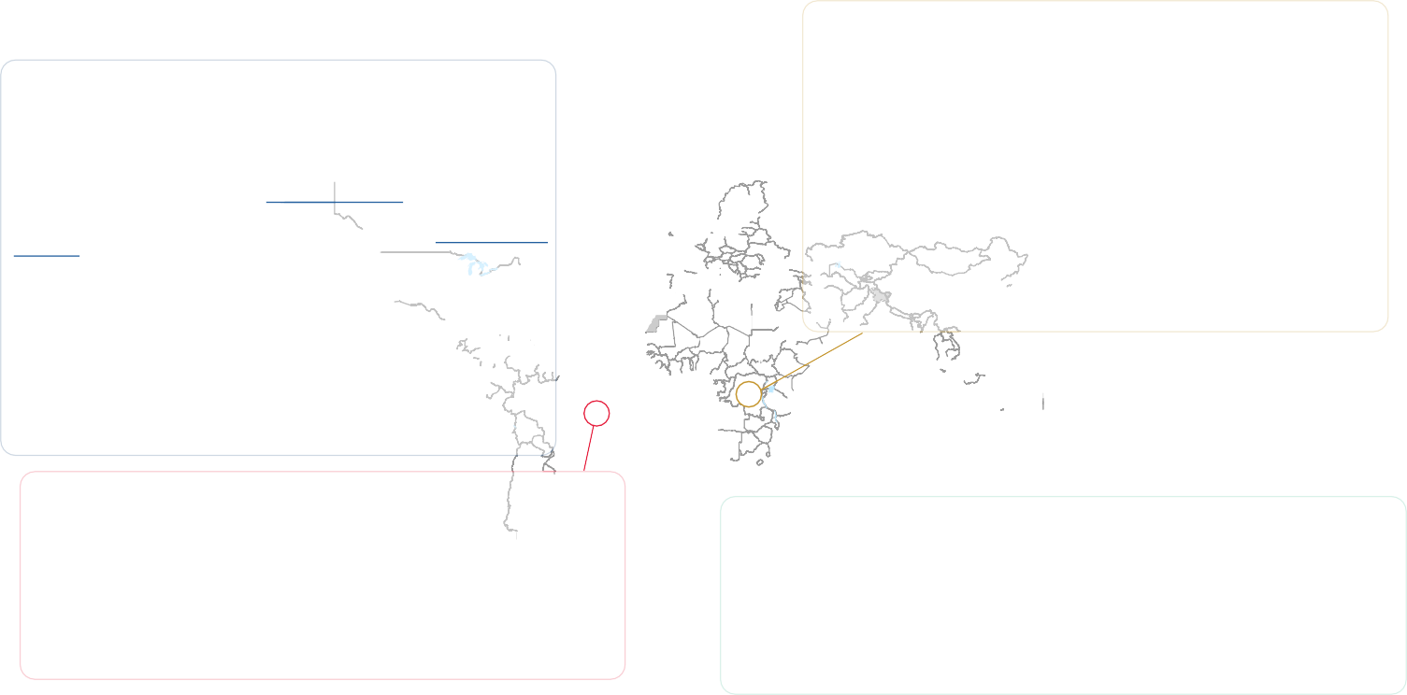

in Kenya, AFRO deployed four experts (coordinator, case manager, Infection Prevention and Control lead and logistician) to support the Ministry of Health in Kenya to develop a preparedness plan for COVID-19 and initiate implementation of preparedness and readiness capacities. At the onset of the pandemic Kenya had only six beds in the highly infectious disease treatment units (HIDTU) in Kenyatta National hospital. PPE was limited, and staff were not trained on COVID-19 case management and IPC. The Mbagathi hospital maternity and newborn unit was repurposed as a COVID-19 treatment facility, and WHO in collaboration with the Ministry of Health assessed the facility in terms of IPC and case management capacity. With support from the logistics pillar and funds donated by the office of the President, Ministries of Health and Finance, WHO and donor partners, the 120-bed facility was made ready on 6 March 2020. In addition, together with the Ministry of Health teams on Case management and IPC, WHO provided five days of training of trainers for a total of 32 high-level medical personnel in critical care management for COVID-19. The objective was for these high-level personnel to identify isolation centres in each of their counties and, based on best IPC standards, to replicate these trainings on case management and IPC.

In total in the African region, more than 3**000** **participants** from ministries of health, provincial and district hospitals, and private medical practices from **172** **locations** **in** **58** **countries** have been trained in COVID-19 clinical characterization, antimicrobial therapy, triage and hospitalization, treatment of severely ill patients, and the criteria and process for the discharge and management of convalescent patients.

##### South-East Asia region

The Regional Office arranged regular updates on the latest IPC guidance to Member States. **Training** **materials/opportunities** **were** **provided** **and** **translation** **of** **OpenWHO** **courses** **on** **infection** **prevention** **and** **control** **into** **local** **languages** **of** **the** **Region** **was** **coordinated**. Country- specific technical advice sessions for Bangladesh, Bhutan, Maldives, Nepal, Sri Lanka and Timor-Leste were also provided. The areas supported were rational use of personal protective equipment (PPE),

its local manufacturing and quality certification, hospital surge planning,

isolation facility management, and disinfectants.

##### Eastern Mediterranean region

EMRO has conducted four virtual trainings for IPC in the context of COVID-19, attended by **35** **healthcare** **workers** in Afghanistan, **40** **IPC** **focal** **points** in Iraq; **75** **clinicians** **and** **critical** **care** **physicians** in Morocco and **50** **clinicians**, including critical care physicians and infectious disease physicians in Pakistan. In addition, a training of trainers was rolled out for **246** **medical** **staff** **o**n IPC and case management from Kabul and 13 high-risk provinces (Afghanistan); 383 nurses from across **290** **hospitals** (Lebanon); **813** **healthcare** **providers** in Somalia; and **60** **ambulance** **drivers** and ambulance personnel in Sudan. For case management, 42 infectious disease and ICU clinicians in Pakistan were trained to care for patients with severe and critical COVID-19. In addition, 25 participants from 16 countries were trained in the use of a supply-management tool to ensure an adequate stock of oxygen, ventilators, and other key items.

EMRO supported countries to ensure continuity of essential mental health services, especially for childhood immunizations, antenatal care, pre-existing conditions and crisis situations. Continuity of care for persons using mental health services was maintained through dedicated helplines and call centres in Afghanistan, Egypt and Morocco, the development and dissemination of awareness raising materials in Afghanistan, Jordan and Morocco, and will be strengthened through plans for referral pathways that will include an online platform and ongoing technical support to partners.

### Operations support and logistics

The COVID-19 pandemic has caused an unprecedented spike in demand for personal protective equipment. In addition,

the laboratory reagents required for testing and the swabs needed for sampling are in short supply. At the same time, commercial transportation routes have almost completely shut down. This has left many countries unable to procure essential items on the open market, and therefore unable to access potentially life-saving equipment (PPE). WHO, working with key procurement and logistics partners, has provided a lifeline, shipping many millions of items of PPE to **111** **countries**, and over **1.5** **million** **laboratory** **testing** **kits** **to** **over** **132** **Member** **States**. But that is just the beginning. Through the new

COVID-19 Supply Chain System, WHO and partners have a further **30** **million** **laboratory** **diagnostic** **kits** in the pipeline, along with over **225** **million** **items** **of** **crucial** **PPE**.

##### European region

Shipments made to 17 countries in the region

Surgical masks: 121 100

N95 masks: 7250

Gloves: 249 100

Gowns: 24 648

Goggles: 4140

Face shield: 7000

##### Region of the Americas

Shipments made to six countries in the region

Surgical masks: 88 000

N95 masks: 2650

Gloves: 88 000

Gowns: 14 020

Goggles: 1500

**Shipped** **(as** **at** **30** **June)**

3 029 650 Surgical masks

128 875 N95 masks

2 040 900 Gloves

203 379 Gowns

36 447 Goggles

102 106 Face shields

1.5 million lab diagnostic kits

**In** **Focus:** Solidarity flights

As border closures and internal travel restrictions remain in place in many countries in Africa, the availability of PPE has become a major challenge in many countries. WHO continues to work closely with WFP, the African Union

(AU), and the governments of Ethiopia and the United Arab Emirates to deliver much-needed medical equipment to countries in Africa to support the response to COVID-19.

In collaboration with the Africa Centres for Disease Control and Prevention (Africa CDC), 25 WFP aviation and logistics staff work around the clock to ensure that medical equipment gets where it is most needed. Thus far, WHO has provided enough PPE to safely treat 30 000 patients with suspected COVID-19.

The Solidarity Flights have further delivered materials (PPE, laboratory supplies and respirators provided by the Jack Ma foundation) to all countries on the continent.

##### South-East Asia region

Shipments made to 11 countries in the region

Surgical masks: 482 000

N95 masks: 43 065

Gloves: 414 500

Gowns: 26 800

Goggles: 10 150

Face shield: 15 336

##### Western Pacific region

Shipments made to 20 countries in the region

Surgical masks: 314 550

N95 masks: 15 365

The deliveries of PPE are absolutely crucial, as healthcare workers are often disproportionately affected by infectious disease outbreaks. There is some evidence that COVID-19 is threatening health workers in Africa. By 26 June 2020, 5984 health workers from 38 countries had been infected, with South Africa having 35% (2084) of all the cases.

Additionally, Nigeria (17%; 987), Ghana (6%; 351) and Cameroon (5%; 325) have recorded the highest proportion of health worker infections. In countries with weak health systems and comparatively smaller numbers of health workers, the consequences of health workers succumbing to COVID-19 are extremely serious. In Cameroon, contact tracing efforts were compromised by the lack of PPE.

#### **In** **Focus:** Getting supplies to Small Island Developing States

As cases began to multiply in the Eastern Caribbean sub- region, PAHO’s technical cooperation supported ten countries to intensify their preparedness efforts to test, identify, isolate and care for COVID-19 patients. However, the response in the Eastern Caribbean faced an added complexity, related to their characteristics being Small Island Developing States (SIDS).

PAHO/WHO’s technical cooperation with the Eastern Caribbean is long established and formed an integral part of the response. Even before there was a confirmed case in any of the ten islands, the PAHO Country Office for Barbados and the Eastern Caribbean was at work through its Incident Management System, coordinating the provision of PPEs and lab supplies, and training of national counterparts in contact tracing and IPC measures. At the outset of the outbreak in the subregion, PAHO/WHO was the only international partner able to provide test kits to the islands.

As the COVID-19 pandemic evolved, PAHO/WHO’s intervention

within the framework of the Caribbean Comprehensive Disaster

Face shield: 7900

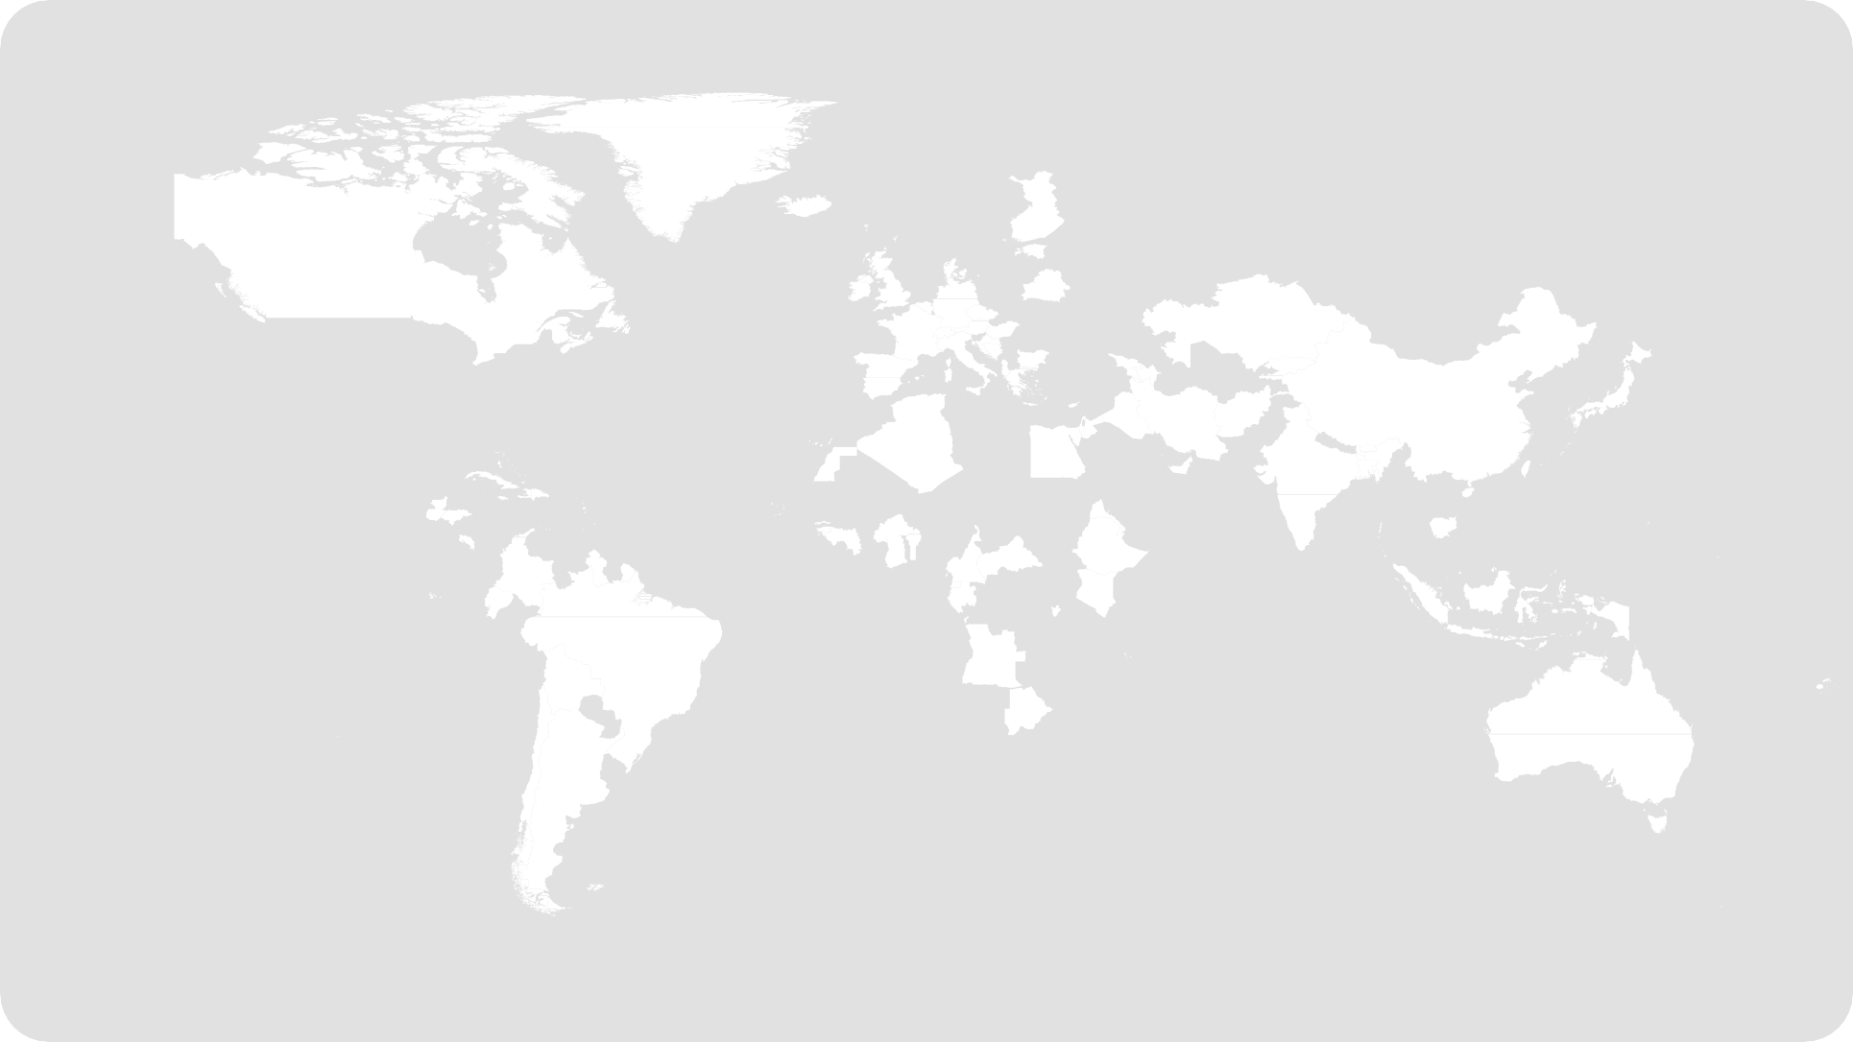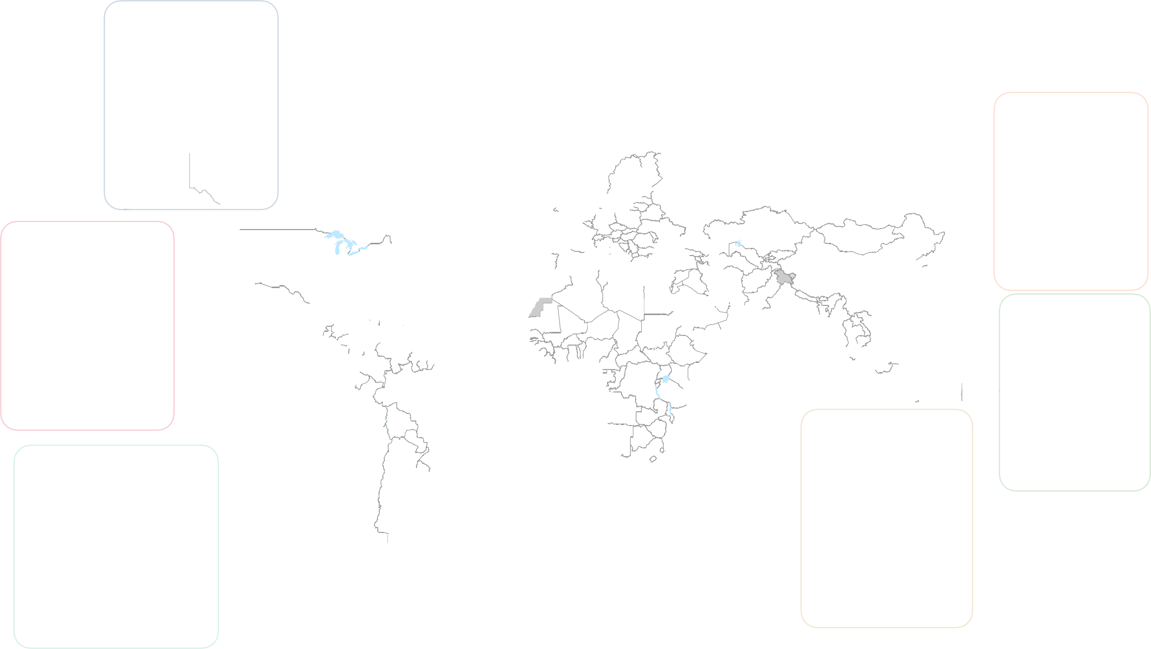

##### Eastern Mediterranean region

Shipments made to 17 countries in the region

Surgical masks: 484 250

N95 masks: 36 345

Gloves: 704 000

Gowns: 81 122

Goggles: 7620

Face shield: 26 760

##### African region

Shipments made to 40 countries in the region

Surgical masks: 1 439 750

N95 masks: 24 200

Gloves: 386 300

Gowns: 46 779

Goggles: 6930

Face shield: 34 510

Gloves: 199 000

Gowns: 10 010

Goggles: 6107

Face shield: 7200

Management Coordination Mechanism made a significant impact. PAHO collaborated with the Regional Security System (RSS), a long-standing partner, responsible for the defence and security of the eastern Caribbean region and the Barbados

Defense Force (BDF) Level I WHO certified Emergency Medical team, to distribute the criical supplies, even amidst the border closures. In this instance, PAHO procured the needed supplies and coordinated the logistics with the operational support of the BDF. Delivery was undertaken by RSS, through various weekly earmarked flights within 48 hours of PAHO/WHO’s receipt of the supplies.

## Accelerating priority research and

term and longer term research priorities based on current knowledge gaps; progress against those priorities has come

**Box** **2** Progress against Gobal Research Roadmap

## innovation

### A Global Research Roadmap and call to action

There are no vaccines against COVID-19, no curative treatments, and a need for diagnostic tests that can produce rapid, accurate results in a variety of different settings at scale. To meet these extraordinary challenges, the world required an emergency mechanism to coordinate global research and development efforts by a diverse range of stakeholders, from academics and industry to national governments. On 11–12 February 2020, WHO convened the [Global Research Forum](https://www.who.int/news-room/events/detail/2020/02/11/default-calendar/global-research-and-innovation-forum-to-mobilize-international-action-in-response-to-the-novel-coronavirus-(2019-ncov)-emergency), engaging a broad group of policy makers, researchers, public health experts, non-governmental organizations, funders, and the private sector. Crucially, the forum engaged researchers from affected countries to set priorities that respond to country needs, and that reduce barriers and maximize opportunities for research at national level.

Using the [WHO R&D Blueprint](https://www.who.int/research-observatory/analyses/rd_blueprint/en/) as its basis, the Forum developed an initial [COVID-19 Global Research Roadmap](https://www.who.int/blueprint/priority-diseases/key-action/Coronavirus_Roadmap_V9.pdf). The roadmap unites the global community around a common research agenda, with a common ambition to accelerate equitable access to affordable and effective medical countermeasures. The Roadmap identified immediate, mid-

at a rapid pace (**Box** **2**).

The Global Research Roadmap, and an accompanying framework for coordinated investment, enables funders and researchers to prioritize investment and research options for COVID-19, and ensures that research adheres to three core principles:

* Speed: to act fast, shorten the development timeline (including collapsing overlapping phases of development), be bold in trying new approaches.
* Scale: by prioritizing the most promising technologies and innovations that can rapidly be brought to scale for the

greatest impact, by enlisting the support of all manufacturers globally, and by implementing innovative approaches to fast- track licensing and the expansion of production capacity.

* Access: by focusing on research and development that puts access at the core of the investment effort, and therefore ensuring affordable and equitable access to those most at risk.

On 24 April, commitment to these principles was set in stone with the announcement of the [Access to COVID-19 Tools](https://www.who.int/who-documents-detail/access-to-covid-19-tools-(act)-accelerator)  [Accelerator: the ACT Accelerator](https://www.who.int/who-documents-detail/access-to-covid-19-tools-(act)-accelerator).

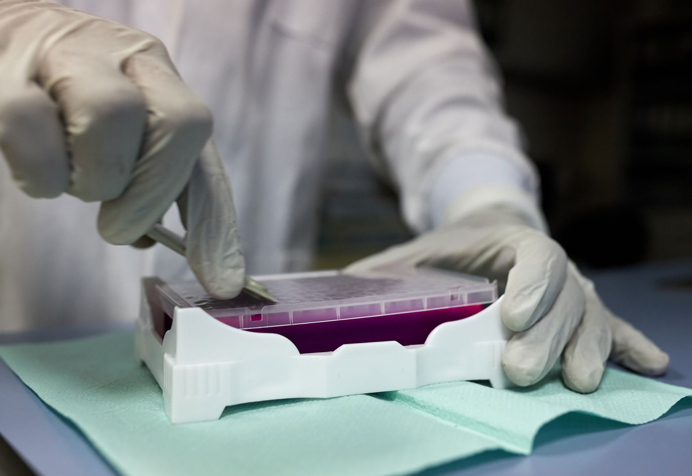

Credit: WHO

By the end of April 2020 WHO had supplied over

1.5 million laboratory diagnostic kits to 125 Member States.

### Transmission

* + [WHO laboratory and biosafety guidance,](https://apps.who.int/iris/bitstream/handle/10665/331509/WHO-COVID-19-lab_testing-2020.1-eng.pdf)  [and diganostic strategy for testing in resource-](https://apps.who.int/iris/bitstream/handle/10665/331509/WHO-COVID-19-lab_testing-2020.1-eng.pdf)

[constrained settings](https://apps.who.int/iris/bitstream/handle/10665/331509/WHO-COVID-19-lab_testing-2020.1-eng.pdf)

* + [Landscape analysis of diagnostic assays in](https://www.who.int/blueprint/priority-diseases/key-action/Table_of_therapeutics_Appendix_17022020.pdf)  [development/available](https://www.who.int/blueprint/priority-diseases/key-action/Table_of_therapeutics_Appendix_17022020.pdf)
  + Studies of viral shedding during acute infection

### Human–animal interface

* + Investigaiton of replication and excretion of COVID-19 in fur farms in China: negative result.
  + Investigaiton of replication and excretion of COVID-19 from pets in contact with human

cases: ongoing

* + Investigation of susceptibility of pets and livestock: ongoing

### Epidemiology

* + Core protocols developed for four early

sero-epi investigations and one environmental

investigation, under the Unity study umbrella

* + Epidemiological studies using one or several of the core Unity protocols have been started in 31

countries

### Clinical management

* + [Clinical management protocol developed](https://www.who.int/emergencies/diseases/novel-coronavirus-2019/technical-guidance/patient-management).
  + Protocols developed to assess transmission

through aerosol/high-flow oxygen

* + Global [anonymized clinical data platform](https://www.who.int/emergencies/diseases/novel-coronavirus-2019/technical-guidance/patient-management) developed for rapid collection of relevant clinical

data

### Health workers and infection prevention and control

* + Systematic reviews of evidence informing IPC guidance for the COVID-19 response, such

as the effectiveness of medical masks versus respirators for health worker protection; physical distancing; utility of universal mask use in public and in health care facilities.

* + Research on optimal features and characteristics of non-medical masks, including

choice of fabric, number and combination of layers, shape, and coating – this research informed WHO [updated guidance on masks](https://www.who.int/emergencies/diseases/novel-coronavirus-2019/technical-guidance/infection-prevention-and-control).

* Researched efficacy and safety of decontamination and re-use methods for masks and

respirators.

* Developed protocol for case–control study to assess risk factors for COVID-19 in health workers.

### Therapeutics

* [Landscape analysis of therapeutics](https://www.who.int/blueprint/priority-diseases/key-action/Table_of_therapeutics_Appendix_17022020.pdf)
* Treatment master protocol developed
* Solidarity trial launched and expanded.
* Agreements finalized with five manufacturers of

medicines included in the Solidarity trial

### Vaccines

* [Landscape analysis of vaccine candidates](https://www.who.int/who-documents-detail/draft-landscape-of-covid-19-candidate-vaccines)
* [Master protocol developed for phase 2b/3 trials](https://www.who.int/blueprint/priority-diseases/key-action/Outline_CoreProtocol_vaccine_trial_09042020.pdf?ua=1)
* [Target product profile produced for COVID-19](https://www.who.int/docs/default-source/blue-print/who-target-product-profiles-for-covid-19-vaccines.pdf?sfvrsn=1d5da7ca_5)

[vaccines](https://www.who.int/docs/default-source/blue-print/who-target-product-profiles-for-covid-19-vaccines.pdf?sfvrsn=1d5da7ca_5)

### Ethics

* Key ethical concepts paper published
* Policy briefs produced on ethics of research for COVID-19; ethics of resource allocation and

equitable access; ethics of restrictive measures

### Social sciences

* Review of pyschosocial impacts of COVID-19
* Review and key lessons of health protection policies
* Research into impacts of quarantine on contraception, HIV treatment access, delivery modes and quality of SRH care
* [Research protocol](https://www.who.int/who-documents-detail/perceptions-of-healthcare-workers-regarding-local-infection-prevention-and-control-procedures-for-covid-19-research-protocol) development and research implementation on health care worker perceptions of infection prevention and control procedures
* [Toolbox on Good Participatory Practice for](https://www.who.int/who-documents-detail/r-d-good-participatory-practice-for-covid-19-clinical-trials-a-toolbox)  [COVID-19 clinical trials](https://www.who.int/who-documents-detail/r-d-good-participatory-practice-for-covid-19-clinical-trials-a-toolbox) and [Working with](https://www.who.int/who-documents-detail/working-with-community-advisory-boards-for-covid-19-related-clinical-studies)  [Community Advisory Boards for COVID-19 related](https://www.who.int/who-documents-detail/working-with-community-advisory-boards-for-covid-19-related-clinical-studies)  [clinical trials](https://www.who.int/who-documents-detail/working-with-community-advisory-boards-for-covid-19-related-clinical-studies)
* Development of rapid reviews on the social, cultural, behavioural considerations on the use of face coverings; immunity passports; and home care

### Coordination

* Global Research Roadmap published
* Framework for coordinated investment in research developed

The landmark collaborative initiative was launched at an event co-hosted by WHO, the President of France, the President

On 18 March, in order to fast-track this research, WHO launched Solidarity – a large international clinical trial to help

#### **In** **Focus:** International solidarity in Spain: on the front line against COVID-19

of the European Commission, and the Bill & Melinda Gates Foundation. The event was joined by the UN Secretary- General, the AU Commission Chairperson, the G20 President, heads of state of France, South Africa, Germany, Vietnam, Costa Rica, Italy, Rwanda, Norway, Spain, Malaysia and the UK (represented by the First Secretary of State), together with health leaders from the Coalition for Epidemic Preparedness Innovations (CEPI), GAVI, the Vaccine Alliance, the Global Fund, UNITAID, the Wellcome Trust, the International Red Cross and Red Crescent Movement (IFRC), the International Federation of Pharmaceutical Manufacturers (IFPMA), the Developing Countries Vaccine Manufacturers’ Network (DCVMN), and the International Generic and Biosimilar Medicines Association (IGBA). Together, this broad coalition committed (**Box** **3**) to work together, guided by a common goal to accelerate the development and equitable global access to safe, quality, effective, and affordable COVID-19 diagnostics, therapeutics and vaccines.

The ACT-Accelerator is organized into four pillars of work: diagnostics, treatment, vaccines and health system strengthening. Each pillar is vital to the overall effort and involves innovation and collaboration.

Cross-cutting all of the work, and fundamental to the goals of the ACT-Accelerator, is the Access and Allocation workstream that is led by WHO and is developing the principles, framework and mechanisms needed to ensure the fair and equitable allocation of these tools.

The launch of the initiative was also a call to action for the global community and political leaders to support the landmark collaboration, and for donors to provide the

necessary resources to deliver on the commitments of the initiative. On 4 May, donors delivered. At a pledging event co- convened by the European Union, Canada, France, Germany,

Italy, Japan, the Kingdom of Saudi Arabia, Norway, Spain and the United Kingdom, donors pledged US$8 billion to the Coronavirus Global Response Initiative, comprised of three partnerships for testing, treating and preventing COVID-19, underpinned by health systems strengthening.

On 1 and 2 July WHO will convene a second Global Forum on COVID-19 Research and Innovation to take stock of

the progress towards meeting the priorities defined in the Global Research Roadmap. The virtual Forum is expected to be attended by over 1200 participants from more than 90 countries, and will be an essential and timely opportunity to

frame the next set of research priorities up to the end of 2020 and beyond.

### Solidarity trial

While the search for an effective treatment for COVID-19 continues, WHO has cautioned against giving unproven treatments to patients with COVID-19 until there is sufficient evidence of benefit. The consensus among experts is that far more testing is urgently needed to determine whether

existing anti-viral drugs can be effectively repurposed to target COVID-19. If proven safe and effective, large numbers of deaths could be avoided through access to one or more of these treatments.

find an effective treatment for COVID-19 . Enrolling patients in one single randomized trial will help facilitate the rapid worldwide comparison of unproven treatments and overcome the risk of multiple small trials not generating the strong evidence needed to determine the relative effectiveness of potential treatments.

To begin with, the Solidarity trial aims to compare four treatment options against standard care, based on evidence from laboratory, animal and clinical studies. The treatments are Remdesivir; Lopinavir/ Ritonavir; Lopinavir/Ritonavir with Interferon beta-1a; and Chloroquine or Hydroxychloroquine.

By enrolling patients in multiple countries, the Solidarity trial aims to rapidly discover whether any of the drugs slow disease progression or improve survival.

In support of the Solidarity trial, WHO negotiated agreements with five manufacturers of the trial drugs that are being donated to participating countries.

By 30 June 2020, more than 5000 patients in 21 countries have enrolled in the Solidarity trial, and their efforts are already yielding important results. At the end of June, interim trial data showed that, when compared with standard of care, hydroxychloroquine and Lopinavir/Ritonavir do not reduce mortality in patients hospitalized with COVID-19. The Solidarity trial invesitgators therefore discontinued those trial arms with immediate effect.

Overall, more than 100 countries representing all six WHO regions have joined or expressed an interest in joining the trial. WHO continues to support each of them to obtain ethical and regulatory approval for the WHO core study protocol; identify hospitals to participate in the trial; train hospital clinicians on the web-based randomization and data system; shipping the trial drugs as requested by each participating country.

### Beyond Solidarity

Beyond the Solidarity trial, WHO is closely monitoring candidate therapeutics through its therapeutic candidates landscape analyses, working with the Covid-19 - living Network Meta-Analysis initiative to track more than 1300 clinical trials an srudies regisered on WHO’s International Clinical Trials Registry Platform.

In addition, WHO’s global research database gathers the latest international multilingual scientific findings and

knowledge on COVID-19. The global literature cited in the WHO COVID-19 database is updated daily from searches of bibliographic databases, hand searching, and the addition of other expert-referred scientific articles.

WHO has also launched Solidarity II: a global collaboration to promote the implementation of serological surveys of SARS-CoV-2. Serological testing detects antibodies in the blood that indicate whether a person has been infected with the SARS-CoV-2 virus that causes COVID-19. By conducting surveys among different populations around the world, we can together understand how frequently infection occurs

Dr Vicente Estrada, a Spanish infectious disease doctor, has dedicated his career to studying and fighting HIV. But when Madrid, where he lives and works, became a hotspot for COVID-19, Dr Estrada and his colleagues had to change priorities. “This pandemic has changed my job and my

activities, and I’m moving to cover it,” he said. “All my time at

this moment is devoted to this pandemic.”

Through the leadership of WHO, Dr Estrada and hundreds of other doctors around the world are now working together to find an effective treatment for COVID-19 through WHO’s Solidarity trial.

With the Solidarity Clinical Trial, WHO has used its international reach and convening power to fast-track and scale up randomized clinical trials around the world to find a treatment for COVID-19 at a rate that aims to be 80% faster than any traditional trial. By enrolling an unprecedented number of patients in a single randomized clinical across multiple countries, WHO is able to test four possible treatment options faster, with the aim of gaining strong evidence for a potential treatment.

Doctors around the world, such as Dr Estrada, have now dedicated themselves full time to the task of identifying

a viable treatment through the Solidarity trial. Through donations from drug manufacturers, WHO has been able to provide potential treatment options for these clinical trials, alleviating the financial and procurement responsibility of already overburdened hospitals. As Dr Estrada confirmed, “We couldn’t have obtained these drugs outside a clinical trial.”

One daunting challenge remains: if a medicine is proven effective, Dr Estrada is particularly worried about ensuring that patients in poorer countries can access affordable treatments. “If these drugs are shown to be effective, I’m concerned about the high cost,” which may not be accessible to low-income and high-income countries alike.

To that end, WHO brought leaders and partners together to launch the Access to COVID-19 Tools (ACT) Accelerator,

a global collaboration to accelerate the development, production, and equitable access to new COVID-19 therapeutics, diagnostics, and vaccines. At the event, Dr Tedros Adhanom Ghebreyesus, WHO Director-General stressed: “Inequity is unacceptable – all tools to address COVID-19 must be available to all. In the fight against COVID-19, no one should be left behind.”

WHO is not only leading the global search for a treatment through the Solidarity Clinical Trial, but also ensuring that when a treatment is found, all COVID-19 patients around the world will have access to it.

It is medical professionals like Dr Estrada who are on the frontlines of this health crisis, not only battling the disease by caring for patients, but also researching medicines and vaccines to get ahead of the pandemic. When asked what gives him hope amidst the crisis and keeps him going, Dr Estrada answered unequivocally, “the solidarity of the health professionals and the unconditional dedication to their work.”

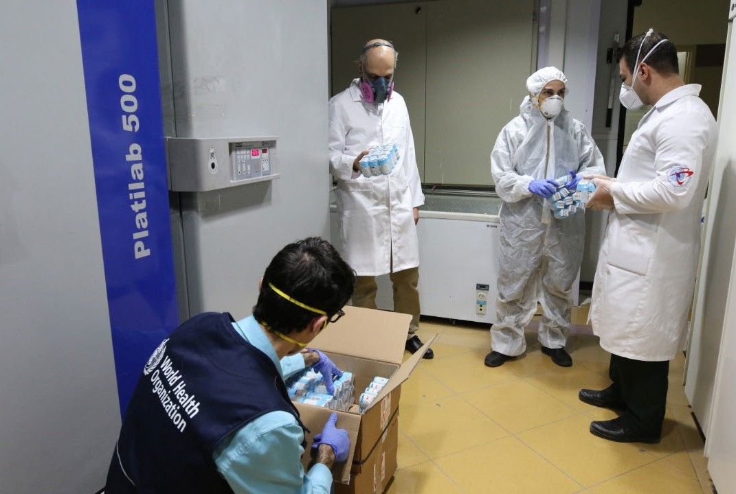

Credit: WHO

Solidarity trial therapeutics are delivered by WHO to researchers in Iran. Iran was

one of 12 countries, along with Norway, Spain, Switzerland, Brazil, Malaysia, Indonesia, the Philippines, India, Saudi Arabia, Honduras and Lebanon, to be taking part in the Solidarity trial before the end of April 2020. A further 12 countries are scheduled to join the trial throughout May. In total, almost 100 countries have expressed an interest in joining the trial. The larger the trial becomes, the faster it will be able to gather crucial data on efficacy.

among different populations, how many people have had mild or asymptomatic infection, how many people have been infected but may not have been identified by routine disease surveillance, and what proportion of the population may be immune from infection by SARS-CoV-2 in the future. Access to this information is crucial to enable local, national, and international decision-makers to calibrate their response to the pandemic.

### Accelerating the development of a safe and effective vaccine

Developing and testing a new vaccine is usually a process that takes many years. In the little over 6 months since the world was first alerted to the danger of COVID-19, the global research community has acted with a speed and agility that is truly unprecedented, in an effort to find a safe and effective vaccine in the shortest time possible. WHO is now tracking

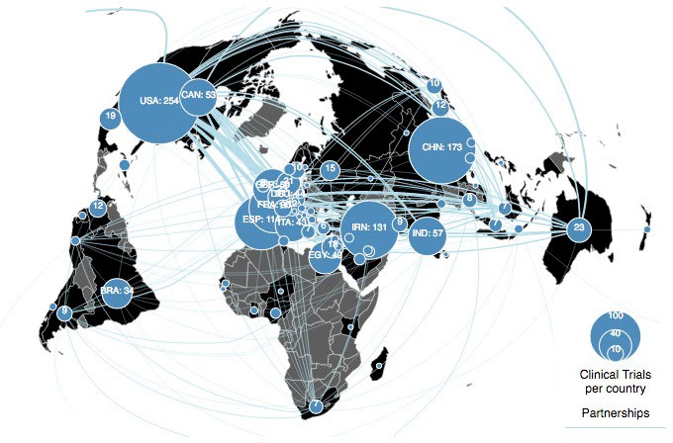The Covid-19 - living Network Meta-Analysis initiative has so far gathered and analysed data from 1327 studies of treatments from WHO’s International Clinical Trials Registry Platform. Over 740 of these trials are currently recruiting patients. The initiative produces a living map of ongoing research in order to identify gaps and deficiencies in real time to help prioritize and optimize future research.

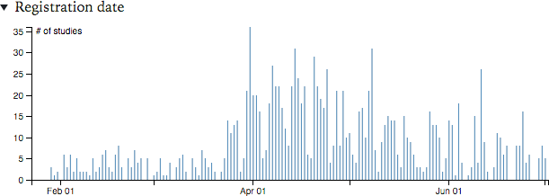

COVID-19 clinical studies registered daily to the end of June 2020

the development of more than 140 candidate vaccines across the world, several of which have already entered late-stage clinical trials. And WHO is playing a vital role in every stage of the development and delivery process, including:

1. | *Harnessing* *a* *broad* *global* *coalition* *to* *develop* *and* *evaluate* *candidate* *vaccines* *as* *quickly* *and* *safely* *as* *possible*

WHO’s core function is to direct and coordinate international

efforts through:

* Global collaboration and cooperation;
* Development of robust methods;
* Working to accelerate progress and avoid duplication of research efforts;
* Coordinating an unparalleled effort to rapidly and simultaneously assess many vaccines.

WHO has brought scientists, developers and funders together to coordinate action, and provide common platforms for working together, including:

* + Developing specific criteria that vaccine scientists, product developers, manufacturers, regulators and funding agencies can use for prioritization. The attributes and criteria lay out some of the considerations that structure WHO’s case-by- case assessments of COVID-19 vaccines in the future, with emphasis on prioritization for Phase IIb/III evaluations.
  + Coordinating the Human challenge studies working group tasked to consider the feasibility, utility, realistic timelines and approximate costs for establishing a closely monitored experimental challenge model of infection with SARS-CoV-2 (fully virulent or attenuated) in healthy adult volunteers.

The Expert Group will also discuss the procedures to be codified and logistical obstacles to be overcome to perform such challenge studies and to propose practical solutions to overcome identified hurdles.

* + Launching a call for interest in engaging on animal studies for vaccine evaluations with 17 laboratories in 8 countries with animal laboratory facilities.
  + Mapping of animal models that can accelerate COVID-19 vaccine and therapeutics development
  + Establishing an Expert Group focusing on COVID-19 viruses, reagents and immune assays. The goal of the group is to advance the development of COVID-19 medical

countermeasures (vaccines and immunotherapeutics). This is being achieved by providing a platform to discuss availability of viruses and key reagents, to share data on immune assays and the potential for cross reactivity of SARS-CoV-2 with other coronaviruses.

1. | *Mapping* *candidate* *vaccines* *and* *their* *progress* *across* *the* *world*

Over 140 vaccines have been proposed across the world and WHO is tracking details in a constantly updated landscape analysis of the types of vaccines under development and their progress through various stages of development.

1. | *Defining the desired characteristics of safe and effective*

*vaccines* *to* *combat* *the* *pandemic*

To guide the efforts of vaccine developers, WHO has drawn up Global Target Product Profiles (TPPs) for COVID-19 vaccine. The TPPs outline the minimum and desired attributes of a safe and effective vaccine, and cover two types of vaccines: vaccines for the long-term protection of people at higher risk of COVID-19, such as healthcare workers; and vaccines that stimulate a rapid onset of immunity for use in response to outbreaks.

1. | *Coordinating* *clinical* *trials* *across* *the* *world* *–* *giving* *humanity* *the* *best* *chance* *of* *safe* *and* *effective* *vaccines* *for* *all*

WHO is proposing to massively accelerate the evaluation of vaccines. Its expert group has designed a core protocol for a global and globally coordinated randomized controlled clinical trial for vaccines. Recognizing the critical importance to world

health of the rapid availability and deployment of effective vaccines against COVID-19, on 9 April WHO published the core protocol for an international, multi-site, individually randomized controlled clinical trial that will enable the concurrent evaluation of benefits and risks of each promising candidate vaccine within 3–6 months of it being made available for the trial.

WHO has also launched a call for expressions of interest from vaccine trial sites around the world using the core protocol which will include several candidate COVID-19 candidates that meet WHO prioritization criteria. This will prepare for the launch of a Solidarity Trial for Vaccines that will build on the platform built for the Therapeutics Solidarity Trial. By the end of June 2020 over 115 sites in 16 countries have expressed an interest in joining a Vaccine Solidarity Trial.

The power of the Vaccine Solidarity Trial is its global ambition, and the potential to rapidly deploy and assess vaccines in areas with high transmission. The results for the efficacy of each vaccine are expected within three to six months and this evidence, combined with data on safety, will inform decisions about whether a vaccine candidate can be used on a wider scale in those countries or regions where the vaccines are being tested.

1. | *Ensuring* *access*

Once a safe and effective vaccine becomes available, it will be vital that it is accessible to everyone who needs it. WHO will continue to work to align research and development, fast- track regulatory approvals, harness manufacturing, and work with funders so that all populations in all countries can access a vaccine as early as possible. To that end, the COVAX Facility forms a key part of the vaccine pillar of the Access to COVID-19 Tools Accelerator. COVAX is co-led by Gavi, the Coalition for Epidemic Preparedness Innovations (CEPI), and WHO, working in partnership with developed and developing country vaccine manufacturers. COVAX aims to accelerate the development and manufacture of COVID-19 vaccines, and to guarantee fair and equitable access for every country in the world by sharing the risks associated with vaccine development, by investing in manufacturing upfront so vaccines can be deployed at scale as soon as they are proven successful, and by pooling procurement and purchasing power to ensure the delivery of sufficient volumes of vaccine to end the acute phase of the pandemic during 2021.

To date, 75 countries have submitted expressions of interest in partnering with up to 90 lower-income countries through the facility, with support for lower-income countries supported through voluntary donations to Gavi’s COVAX Advance Market Commitment. Together, this group of up to 165

countries represents more than 60% of the world’s population. Among the group are representatives from every continent and more than half of the world’s G20 economies.



**In** **focus:** Africa COVID-19 hackathon

In the first week of April 2020, the WHO Regional Office for Africa hosted its first [Hackathon](https://www.afro.who.int/news/who-africa-holds-first-hackathon-covid-19), bringing together 100 leading innovators from across sub-Saharan Africa in a bid to pioneer creative local solutions to the COVID-19 pandemic and address critical gaps in the regional response.

Through a facilitated process, participants were tasked with developing innovative and scalable approaches and tools aligned with one of the pillars of the COVID-19 country response strategy, including coordination; surveillance;

risk communication and community engagement; points of entry; laboratory; infection prevention and control; case management and continuity of essential health services; and operational and logistics support. Based on the adjudication process by experts, three innovations have since received seed funding amounting to US$ 22 500

to further develop their innovations and to pilot them in different settings.

Proposals received ranged from mobile-driven self- diagnosis, screening and mapping tools, to alternative low- cost methods for producing personal protective equipment. The WHO hackathon initiative received wide coverage in international media and endorsements from many regional and international stakeholders as one of the key initiatives from Africa that fosters development of local solutions to address local challenges posed by COVID-19 pandemic.

The initiative has since been scaled up through innovative partnership with the African Development Bank (AfDB)

to promote strategic and operational coordination that resulted in ramping up development of non-health-sector solutions to tackle some of the most pressing challenges created by the Covid-19 pandemic. This led to the launch of the #AfricaVsVirus Challenge initiative by AfDB in partnership with WHO on 17 April 2020. WHO has also received additional resources from other international donors to directly support continuity of the WHO hackathon initiative beyond COVID-19.

One of the selected innovations, NextGenCoviAI, is an integrated digital platform for COVID-19 management, risk factors assessment and diagnosis, which has since been rolled out at Mbarara Regional Referral Hospital in Uganda.

**Box** **3** The Access to COVID-19 Tools (ACT) Accelerator Commitment

We commit to the shared aim of equitable global access to innovative tools for COVID-19 for all.

We commit to an unprecedented level of partnership – proactively engaging stakeholders, aligning

and coordinating efforts, building on existing collaborations, collectively devising solutions, and grounding our partnership in transparency, and science.

We commit to create a strong unified voice to maximize impact, recognizing this is not about singular decision-making authority, but rather collective problem-solving, interconnectedness and inclusivity, where all stakeholders can connect and benefit from the expertise, knowledge and activities of this shared action-oriented platform.

We commit to build on past experiences towards achieving this objective, including ensuring that every activity we undertake is executed through the lens of equitable global access, and that the voices of the communities most affected are heard.

We commit to be accountable to the world, to communities, and to one another. We are coming together in the spirit of solidarity, and in the service of humanity, to achieve our mission and vision.

43

COVID-19: February–June progress report

44

COVID-19: February–June progress report



# THE ROAD AHEAD

By working together with countries, partners, and communities, we have achieved a great deal in six months that have seen the world changed by COVID-19, and WHO change with it. The Organization has acted at a speed, scale, with a unity of purpose, and in coordination with its UN and global partners in a way that is unparalleled in its history. Yet there is so much more to do, and there is no time to waste.

The vast majority (86%) of countries now have a national COVID-19 plan, but many need targeted operational support and technical support to be able to fully implement them.

The COVID-19 Partners Platform provides an up to date overview of the overall needs and resources available, enabling transparent and informed planning, implementation, and resourcing, and donors are encouraged to continue to support plans through the portal. At the same time, WHO as part of the IASC has identified 63 priority countries as part

of the GHRP that require more targeted support to rapidly strengthen and/or provide essential response capacity and essential health service continuity.

The scale of the challenge is huge, with significant shortfalls in key capacities in priority GHRP countries as the pandemic continues to accelerate (figure 5). Although almost all

GHRP countries now have a national COVID-19 risk communication and community engagement plan, only half of priority countries have a functional risk communication and community engagement coordination mechanism. Less than a third of priority countries have identified a set of core essential health services to be maintained. Less than half priority countries have a focal point for infection prevention and control training within the Incident Management and Support Team, limiting their ability to scale up IPC capacity. And over two-thirds of priority countries have had to suspend immunization campaigns because of COVID-19. Half of suspended programmes are Polio campaigns, with 20% of

suspensions hitting Mumps, Measles & Rubella campaigns. At present, more than 110 million people in priority countries are at risk of missing a scheduled measles vaccination in 2020.

Without urgent action these countries will see decades of development gains wiped out, with consequences that will last for generations to come.

Based on this urgent need, WHO requires a total of US$ 1.368 billion to support preparedness and response in the 63 GHRP and other high vulnerability/high risk priority countries. In addition, WHO requires US$ 237 million to cover the estimated costs of international coordination and operations, including continuing the operation of the COVID-19 Supply Chain System that has already obtained more than 140 million items of personal protective equipment, 4.5 million laboratory test kits, and 5 million sample collection kits that are available and scheduled for delivery throughout July and August 2020 alone.

Continuing urgent work to accelerate and coordinate research and development will require a further US$ 135 million until the end of 2020. As research and development efforts such as WHO’s Solidarity Trial continue to bear fruit, WHO must work with partners to coordinate global action and leadership to ensure the benefits of research are shared equitably.

In total, US$1.74 billion (table 7) is needed to respond to COVID-19 across the three levels of the organization until the end of December 2020. WHO’s resource requirement is necessary to provide support at global, regional and

country level for all pillars of public health response, including maintaining essential health services, and includes health needs under the Global Humanitarian Response Plan for

**Table** **7** Overview of WHO resource requirements:

January to December 2020

|  |  |
| --- | --- |
|  | **Requirement** **(million** **US$)** |
| Global and regional coordination and support | 237 |
| Support to COVID-19 national plans | 1368 |
| Research and development | 135 |
| **Total** | **1740** |

**Figure** 6 WHO funding received and funding gap as at 30 June 2020

US$ 0.72 billion received by WHO to 30 June 2020

**Figure** **5** Key performance and situation indicators for 63 GHRP priority countries: data as at 30 June 2020

**Proportion** **of** **priority** **countries** **and** **territories** **with** **an** **active** **risk** **communication** **and** **community** **engagement** **coordination** **mechanism** (**target** **100%**)

**52.4%**

**Proportion** **of** **priority** **countries** **and** **territories** **where** **the** **Incident** **Management** **Support** **Team** **has** **a** **focal** **point** **for** **IPC** **training** (**target** **100%**)

**49.2%**

**Proportion of priority countries and territories that have identified a set of core essential services** (**target** **100%**)

**22.2%**

**Proportion** **of** **priority** **countries** **and** **territories** **in** **which** **at** **least** **one** **immunization** **campaign** **has** **been** **suspended** **or** **postponed** **due** **to** **COVID-19** (**target** **0%**)

**68.3%**

**Proportion** **of** **priority** **countries** **and** **territories** **with** **a** **multisectoral** **mental** **health** **and** **psychosocial** **support** **technical** **working** **group** (**target** **100%**)

**44.4%**

humanitarian settings. Taking into account the funds that WHO has received to date (see table 2 above), the funding gap stands at over US$ 1 billion for 2020 (figure 6).

Flexible funding will be key to enabling WHO and its partners to respond effectively and equitably. In a rapidly evolving situation such as this pandemic, the needs and priorities of countries can change at a moment’s notice. COVID-19 has heightened

inequalities across every part of society, and between countries. Funding that is earmarked for use for specific countries or activities makes it more difficult to divide available respources equitably on the basis of need, which can in turn impair the ability of WHO and partners to support response efforts where that support is most crucial.

As at 30 June 2020, the world stands at a pivotal juncture in the course of the pandemic. Collaborative research and

knowledge sharing have helped to answer some of the crucial questions about the benefits and costs of different response strategies in different contexts, the transmissibility of the virus, the clinical spectrum of the disease, and its capacity to rapidly overwhelm even the most resilient health systems. We know that when countries take a comprehensive approach based on fundamental public health measures and a whole-of-society approach COVID-19 can be brought under control, and this can herald the reopening of societies and economies in a prudent, step-wise manner. A false dichotomy is often presented,

where we are told to choose between saving economies and controlling COVID-19. Societies and economies can only function, recover, and adapt where and when the virus has been controlled. COVID-19 is a disease that thrives on delay, denial, and division; we can beat it with rapid coordinated action, clarity and scientific endeavor, and unity of purpose. COVID-19 is a truly global crisis: the only way to overcome it is together, in global solidarity.

US$ 1.02 billion required by WHO to end December 2020



45 46

COVID-19: February–June progress report COVID-19: February–June progress report

**World** **Health** **Organization** **Avenue** **Appia** **20**



**1211** **Geneva** **27** **Switzerland**

**WHO** **in** **Emergencies:** [**www.who.int/emergencies/en**](http://www.who.int/emergencies/en)